SURVIVAL SHEET: Math 162 - section 001

Spring Semester 2016

Textbook: George Thomas, et al, Thomas’ Calculus: Early Transcendentals
(Part 1: Single Variable), 13th edition, Addison-Wesley (2014), packaged with MyMathLab or MyMathLab stand-alone.
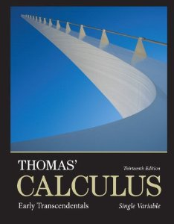

Calculator: The TI-83 Plus or TI-84 Plus graphing calculator or equivalent is required.
Software: Mathematica 9 or 10
Instructor: A. Saleski, 612 BVM Hall (contiguous with IES) building # 37 on map 6349 N. Kenmore Ave., Chicago, IL 60660
phone: (773) 508-3577
e-mail: asalesk@luc.edu OR alan.saleski@gmail.com
Course URL:
http://www.math.luc.edu/~ajs/courses/162spring2016/index.pdf

Office Hours:
MWF 2 – 4 pm;
TTh 4 – 5 pm;
or by appointment.

Ground Rules: The final grade is computed according to the following recipe:

Quizzes | 23 %
Tests | 29 %
Group HW | 10%
In-class groupwork | 4%
Labs | 4 %
Final Exam | 30 %
Extra credit (piazza, etc)

Important Dates:

• Quizzes: Fridays: January 22nd, 29th; February 5th, 19th, 26th; March 4th; April 1st, 8th
• Tests: Fridays: February 12th, March 18th, April 15th
• Holidays:
- Martin Luther King, Jr, Day: Monday, January 19th
- Spring break: Monday – Friday, March 7th – 12th
- Easter break: Friday – Monday, March 24th – March 28th
• Last Day to Withdraw: Tuesday, March 29th (5:00 pm)
• Last Day of Class: Friday, April 29th
• Final Exam: Saturday, May 5th, 1 – 3 pm
• Loyola Calendar (Spring Semester of 2016)

Tutoring Services:
The Center for Tutoring & Academic Excellence offers free Small Group tutoring for Loyola students. The groups meet once a week through the end of the semester and are led by a peer tutor who has successfully completed study in the course material and beyond. Drop-in tutor-led Study Hall hours are also available through the end of the semester. There is no need to make an appointment for Study Hall hours, simply bring your coursework and there will be tutors on hand to assist you. To learn more or to request tutoring services, visit the Center online at www.luc.edu/tutoring.

Remarks:
- Piazza will be our main form of communication outside of class. Upon receiving your welcome message from Piazza, you should join. Any corrections, changes in office hours, “what to expect on a test or quiz”, etc., will be posted in Piazza. The system is highly catered to getting you help fast and efficiently from classmates, the TA, and myself. Rather than emailing questions to the teaching staff, you should post your questions on Piazza. If you have any problems or feedback for the developers, email team@piazza.com.

- All general questions/remarks/solutions should be posted in Piazza. If you wish to make a personal statement, it might be best to email me directly (although the option of private messages does exist in Piazza).

- Quizzes will be based upon material recently covered in class. Each quiz is given during the last 35 minutes of Friday’s class. The lowest two of the eight quiz grades will be dropped.

- The duration of each test is 100 minutes. Make-up tests will be given only for non-frivolous reasons. In such cases, the student should make prior arrangements with the instructor, if at all possible.

- The minimum penalty for cheating is failure in the course. A student who improperly aids another with a homework assignment, a test, the essay, the final exam, or with a Mathematica lab is considered to be equally culpable. If you receive help on an assignment from anyone other than the instructor (this includes another student, a TA, a tutor, a family member, website, or friend), you should acknowledge this fact in a comment at the beginning of your homework or project. Incidents of academic dishonesty will be reported to the appropriate Dean.

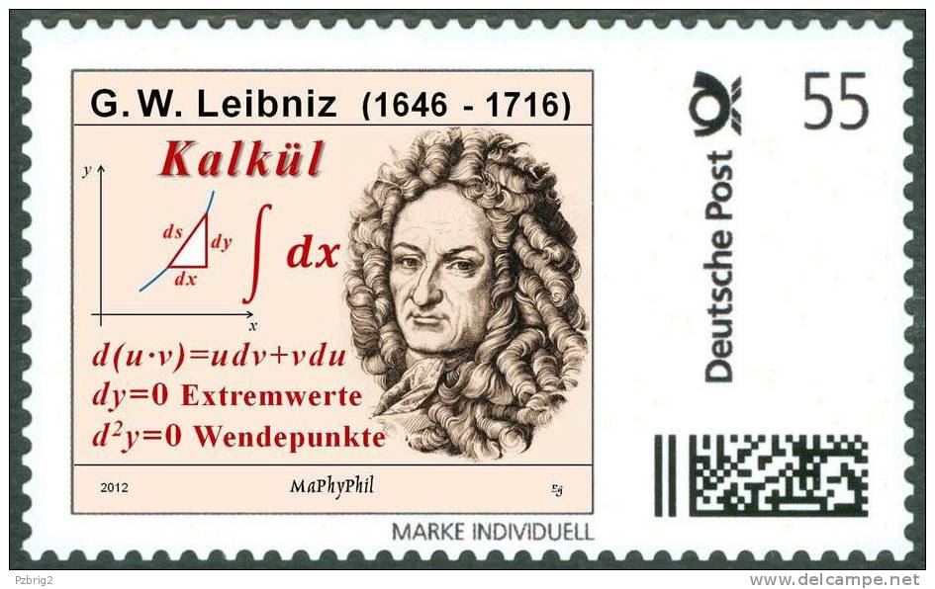

The goal of intellectual education is not to know how to repeat or retain ready-made truths (a truth that is parroted is only a half-truth). It is in learning to master the truth by oneself at the risk of losing a lot of time and of going through all the round about ways that are inherent in real activity.
- Jean Piaget

Course Home Page Department Home Page Loyola Home Page

