GW II Math 162
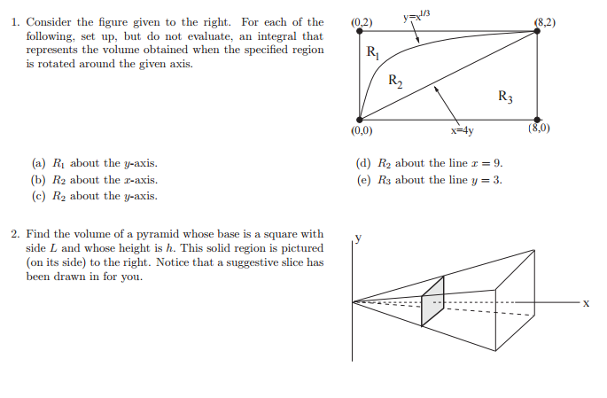
3. Repeat question 1, except this time each figure is rotated about the line
(a) x = -2 (b) x = 15 (c) y = -5 (d) y = 7

