Math 162 (in-class Groupwork: review problems from Univ. Michigan calculus 2)
- O-guk, the monkey, is already very fast. Determined to be the world’s fastest, he works out on a daily basis. After a lot of training he is delighted to participate in the 21st World’s Running Tournament. He managed to reach the final round where he must run for 10 seconds and travel as far as possible in a straight line. Here is a table that gives his velocity v(t), in m/s, t seconds after he begins running in the final round. Assume that v(t) is monotonic between the values given.
t | 0 | 1 | 2 | 3 | 4 | 5 | 6 | 7 | 8 | 9 | 10
v(t) | 8 | 12 | 14 | 15 | 17 | 20 | 22 | 24 | 28 | 30 | 32
  - Estimate the total distance O-guk travels over the first 4 seconds using a left Riemann sum with 2 subdivisions. For another estimate, use a right Riemann sum with 4 subdivisions. In each case, is your answer an underestimate or an overestimate?
  - Estimate O-guk’s average velocity between t = 6 and t = 9 using a Riemann sum.
  - His opponent in the final traveled 214.3 meters over the 10 seconds. Did O-guk win the tournament?
- The following is a graph of a function f(x):
x
f
(
x
)
-7
-5
-3
-2
-1
1
2
3
5
7
2
-1
-2
Note that the graph of f(x) is a semicircle between x = −6 and x = −4, as well as between x = 4 and x = 6.
  - Let F be an antiderivative of f with F(0) = 0. Carefully sketch a graph of F(x).
  - Is the function F even, odd or neither?
- (a) Consider the functions
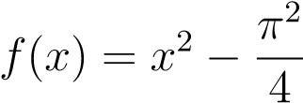 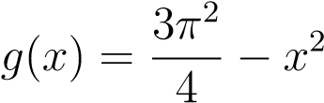 h(x) = cos x
Calculate the area of the region enclosed by the graphs of f, g and h that contains a portion of the y-axis.
(b) The previous problem can be solved in at least two different ways. Describe with words and a picture a different way to find the area (than you used for (a)).
- Consider the integral
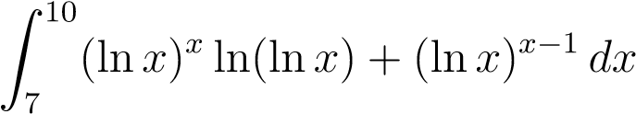
  - Estimate this integral using a Riemann sum with 3 subdivisions.
  - In this question you are asked to find the the exact value of the integral following the following steps:
    - Calculate the derivative of the function F(x) = (lnx)^{x}. (Hint: The identity e^{blna} = a^{b} may be helpful here).
    - Use your previous result to calculate the integral.
- (a) Write a formula for the function whose derivative is e^{2x} and its graph passes through the point (0,−1).
  - Write a formula for the function whose derivative is e^{x2} and its graph passes through the point (0,−1).
  - Let
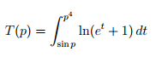
Calculate .dT/dp

