Math 162 GW III (solids) 27 January 2016
U. Michigan exam problems
Problem 1
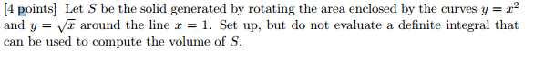
Problem 2
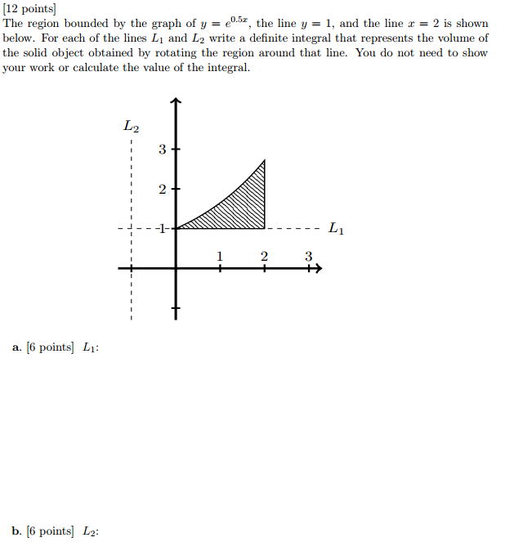

Problem 3
