Math 162 GW V 3 February 2016
Problem 1
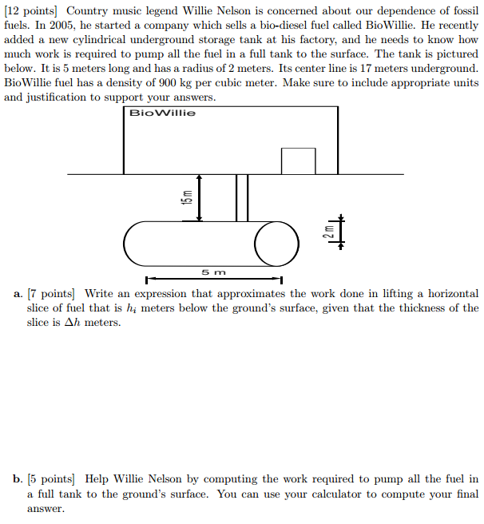

Problem 2
Recall the quiz 2 problem. Now compute the work done in digging the hole.

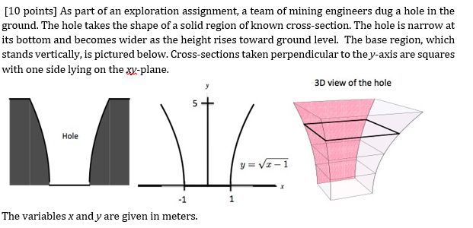
The density of the soil is 1600 kg

Problem 3

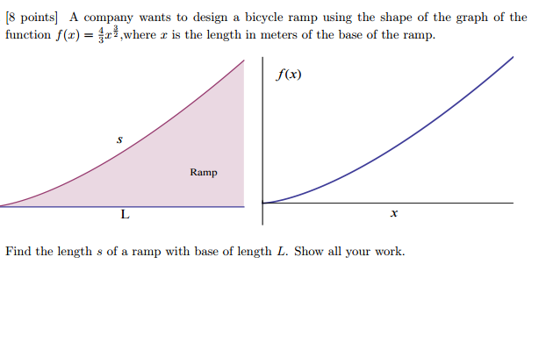

Problem 4
