Math 162 GW VI 29 February 2016
Problems chosen from University of Michigan final exams.
Problem 1
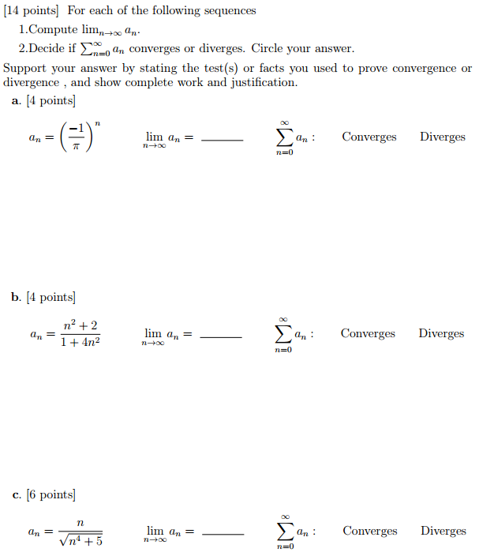

Problem 2
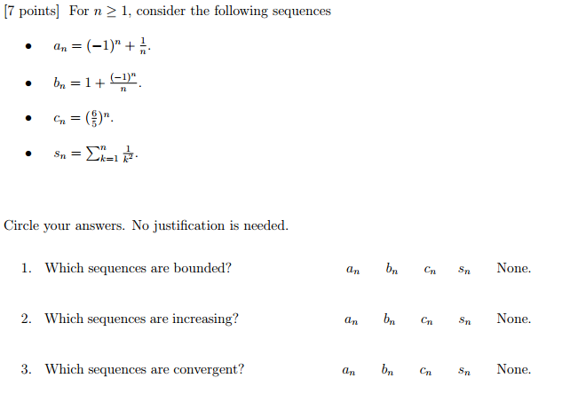

Problem 3
