Group Work Assignments

GW I (20 January): calculus I problems from the University of Michigan
GW II (25 January): volume (probs from Hughes-Hallett)
GW III (27 January): practice quiz II & U. Michigan probs
GW IV (1 February): problems from worksheets 4 and 5 (arc length)

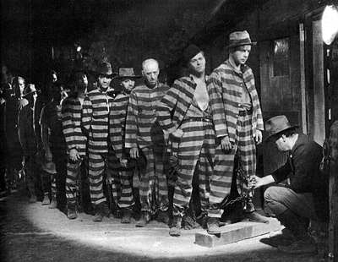
I Am A Fugitive from a Chain Gang (1932)

Course Home Page Department Home Page Loyola Home Page

