**WORKSHEET IV (revised)**

Parametric equations – a brief introduction



1. Sketch the curve x(t) = 3t, y(t) = t2 + 1. Express *y* as a function of *x*.
2. Describe the parameterized curve x(t) = 3 cos t, y(t) = 4 cos t, 0 ≤ t ≤ 2.

What is the relationship between the given curve above and each of the following?

1. x(t) = -3 cos t, y(t) = 4 cos t, 0 ≤ t ≤ 2.
2. x(t) = 3 cos 2t, y(t) = 4 cos 2t, 0 ≤ t ≤ 2.
3. x(t) = 1 – 3 cos 2t, y(t) = 1 – 4 cos 2t, 0 ≤ t ≤ 2.
4. Show that the following is a parameterization of the [cycloid](http://mathworld.wolfram.com/Cycloid.html):

x() = a( – sin ), y() = a(1 – cos ), -∞ <  < ∞.

1. Show that x = a cos t + h, y = b sin t + k, 0 ≤ t ≤ 2 is a parametric equation of an ellipse with center at (h, k) and axes of length 2a and 2b.

5. Find a parameterization of the straight line y = 3x + 4.

6. Find a parameterization of the straight line segment joining the points P = (3, 5) to Q = (7, 11).

7. Find a parameterization of the curve y = x2 from

P = (-1, 1) to Q = (4, 16).

8. Generalize problem 7 for any curve of the form y = f(x) from

x = a to x = b.

9. Find an equation of a line tangent to the given curve at the given point.

(a) x = sin 2pt, y = cos 2pt, t = -1/6

(b) x = 1/t, y = -2 + ln t, t = 1

(c) x = t – sin t, y = 1 – cos t, t = p/3

(d) x = t + et, y = 1 – et, t = 0.

10. Find d2y/dx2 as a function of time if x = t – t2 and y = t – t3.

11. Find an equation for the line in the xy-plane that is tangent to the curve

X = ½ tan t, y = ½ sect t, at t = p/3. Also find d2y/dx2 at the given point.

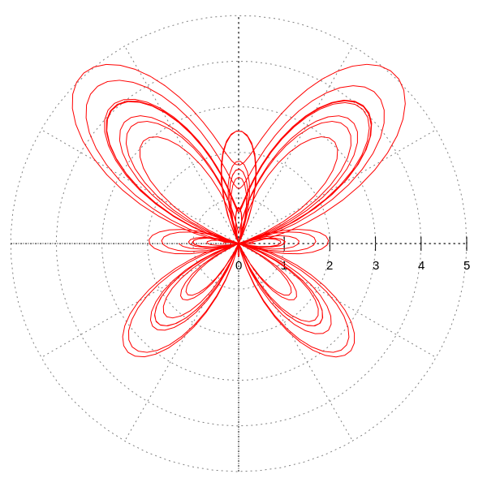

[*the butterfly curve*](http://en.wikipedia.org/wiki/Butterfly_curve_(transcendental))

[Course Home Page](http://www.math.luc.edu/~ajs/courses/162spring2016/index.pdf)          [Department Home Page](http://www.math.luc.edu/)        [Loyola Home Page](http://www.luc.edu/)