Math 162 - Calculus II

Spring 2016
Section 001: MWF 9:20 - 11:15 am (235 Dumbach Hall)
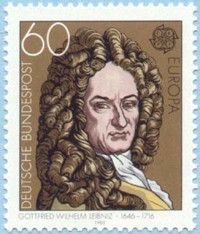
- Ground Rules
- Syllabus
- Homework & Reading Assignments
- Piazza
- Group Work
- Worksheets
- MyMathLab (Getting Started)
- Tutoring Services and Schedule
- Practice Quizzes (Qz 2A, Qz 2B, Qz 2C, Qz 3, Qz 4, Qz 5, Qz 6, Qz 7)
- Practice Tests (T 1, T 2A, T 2B, T 3)
- Practice Finals
- Team Assignments (A1, A2)
- Mathematica Examples (revolution, improper integrals, sequences, Taylor series)
- Mathematica Labs (Lab I, Lab II, Lab III, Lab IV)
- Quiz Solutions (Qz I, Qz II, Qz III, Quiz IV, Qz V, Qz VI, Qz VII)
- Test Solutions (Test I, Test II)
- Final Exam Review Sheet
- Useful References (Greek alphabet; Mathematica tutorials, relevant websites & supplementary texts)
- Student Resources for Thomas
- MIT OCW for Calculus
- History of Calculus

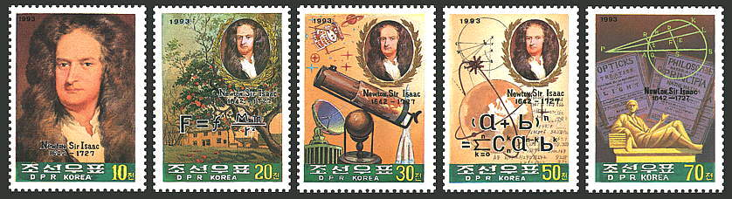

Department Home Page Loyola Home Page

