**Mathematica Lab IV**

**Taylor Series**

(Due: 28 April 2016)

**I    Power Series**

1.    Find the 8th order Maclaurin polynomial of  tanh(x).

2.    Find the 7th order Taylor polynomial of ex about x = 1.

3.    Find the 9th order Maclaurin polynomial of ln(1+x).

4.   Plot the graph of y = ex along with the first four Maclaurin polynomials of ex on the same set of axes.

5. Find the 14th order Maclaurin polynomial of exp(x2). Can you see how this polynomial is related to the 7th order Maclaurin polynomial of ex ? Explain.

**II Weierstrass’ example**

Here we examine a function defined by an infinite series (that is not a power series) which is continuous but nowhere differentiable.



6. Plot the *nth* partial sum of f(x) for several values of *n* (for example, n = 3, 5, 8). Why might you believe that f(x) is not differentiable?

**III   Infinite products**

In mathematics, infinite products play an important role, although perhaps not quite as important a role as that of infinite series.  Analogous to infinite series, an infinite product is the limit of a sequence of partial products.  The capital Greek letter, pi, is used to indicate a product.  For example,



denotes the product:   a(1)a(2)a(3)...a(n).    If we wish to define an *infinite product*, we could let  p(n) = a(1)a(2)a(3)...a(n) and define the infinite product to equal the limit of p(n) as n increases without bound, if the limit exists.  Of course, if the limit does not exist, we say that the infinite product diverges.

7. Examine the infinite products defined by a(n) = 1 + 1/n   and  b(n) = 1 + 1/n2.   Graph each sequence of partial products.  Does either infinite product converge?  If so, what is its limit?

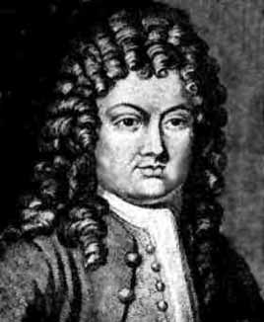

# [Brook Taylor](http://www-groups.dcs.st-and.ac.uk/~history/Mathematicians/Taylor.html) (1685 – 1731)

[Course Home Page](http://www.math.luc.edu/~ajs/courses/162spring2016/index.pdf)          [Department Home Page](http://www.math.luc.edu/)        [Loyola Home Page](http://www.luc.edu/)