Math 162: Mathematica Tutorials and websites

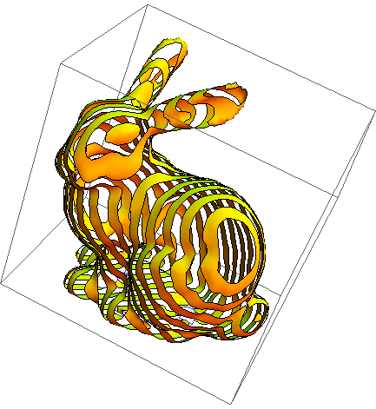

- "Hands-on Start to Mathematica" (several 10-minute online training videos that introduce key features of Mathematica)
- A companion website for Thomas: Student resources for Thomas, including a Mathematica manual
- Additional resources for learning Mathematica, Wolfram Learning Center
- Mathematica For Beginners: The Basics (youTube)

- Mathematica Basics (youTube)

- Stephen Wolfram's Introduction to the Wolfram Language (youTube)

- Stephen Wolfram TED talk: Computing a theory of everything (youTube)

Course Home Page Department Home Page Loyola Home Page

