**MATH 162 Practice QUIZ III**

|  |  |
| --- | --- |
| http://upload.wikimedia.org/wikipedia/commons/thumb/c/c9/Lissajous_curve_9by8.svg/600px-Lissajous_curve_9by8.svg.png | [Lissajous figure](http://www.britannica.com/EBchecked/topic/343305/Lissajous-figure) parameterized by  x(t) = 4 sin (9t), y(t) = 7 sin (8t + /2),  where 0 ≤ t ≤ 2  |

1. Find a parameterization of the circle centered at C = (7, 11) that has

radius equal to 4. Choose the *clockwise* direction.

2. How many *complete cycles* will Charlotte make if she lives on the following parameterized curve: x(t) = 5 cos 20 y(t) = 5 sin 20  where 0 ≤ t ≤ 1?

3. Find a parameterization of the line segment beginning at P = (-3, 4) and terminating at Q = (9, 9).

4. Sketch and identify the curve defined by the parametric equations:

x(t) = 1 + 13 cos t, y = 3 + 13 sin t, where 0 ≤ t ≤  ?

5. Parameterize *one cycle* of the curve y = sin 14x.

6. Sketch and identify the curve defined by the parametric equations:

x(t) = t2 – t, y(t) = 3t – 1

7. Find the arc length of each of the following three curves:



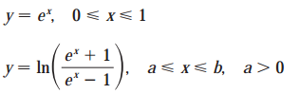

***8.*** Find a curve through the point (e, 4) in the xy-plane whose arc length from x = 1 to x = 7 is given by:

**

***9.*** Charlotte, the spider, lives on the xy-plane. At time *t* (minutes), she is located at x(t) = cos t and y(t) = sin2 t (units in meters) where distance is measured in yards. *How far* does Charlotte travel from t = 0 to t = /2 minutes? *(You need not evaluate the integral.)*



***10.*** Find the area of the surface obtained by rotating the curve about the *x-axis*. (You need not evaluate the integral.) Sketch.

11. 





12. 





13. Find the surface area obtained when the parameterized curve x = sin t, y = t2 + t, 0 t 

is rotated about (a) the x-axis, (b) the y-axis, (c) the line x = 9, (d) the line y = -1.

14.



***15.*** An inverted conical tank of height 20 feet and base radius of 10 feet is filled with olive oil weighing 51 lb/ft3. How much work does it take to pump all of the oil to the rim of the tank?

***16.*** A swimming pool has the shape shown below:



If the pool is 13 ft. deep, how much work is done in pumping all the water out? (*Note:* Water weighs 62.4 lbs per cubic foot.)

***17.*** The Great Cone of Alphaville was built by high school students during their summer vacation. The cone is 100 feet high and its base has a diameter of 80 ft. It has been built from bricks (made of straw) which weigh 3 lbs/ft3. Express as a Riemann integral the amount of work done in building the Great Cone. 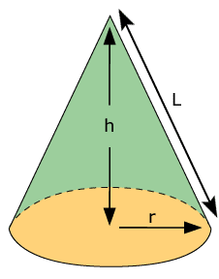

***18.*** A chlorine solution is poured over the surface of a rectangular swimming pool that is 20 meters long, 13 meters wide, and 2 meters deep everywhere. Before the circulating pumps are turned on, it is discovered that the density of the chlorine solution at a height *h* meters above the bottom of the pool is given by (h) = 100(2 – h) gm/m3. (That is, the chlorine solution’s density is greater near the bottom of the pool.)

1. Express the total mass of chlorine in the pool as a Riemann sum.
2. Transform the Riemann sum of part (a) into a definite integral that gives the total mass of the chlorine solution in the pool. Evaluate the integral.

***19.*** The density of cars (in cars per kilometer) down a 20 km stretch of the Auto-Route near Bordeaux is given by (x) = 600 + 120 sin(x) where *x* is the distance in miles from the toll plaza and 0 ≤ x ≤ 20.

1. Write a Riemann sum that estimates the total number of cars along this 20 km stretch.
2. Convert this sum to a Riemann integral and evaluate it.

20. Match the graphs of the parametric equations x = f(t) and y = g(t) in (a)–(d) with the parametric curves labeled I–IV. Give reasons for your choices.

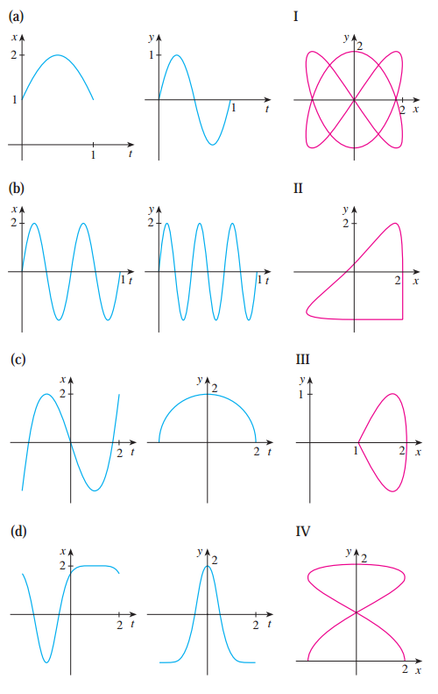

21. Match the parametric equations with the graphs labeled I-VI. Give reasons for your choices. (Do not use a graphing device.)

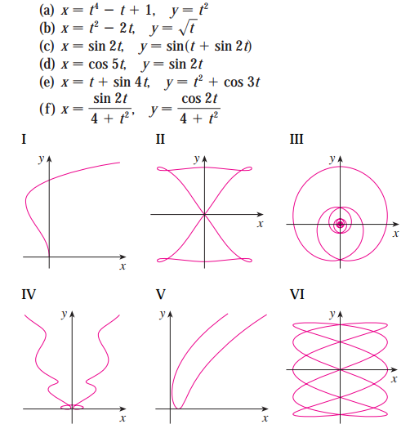

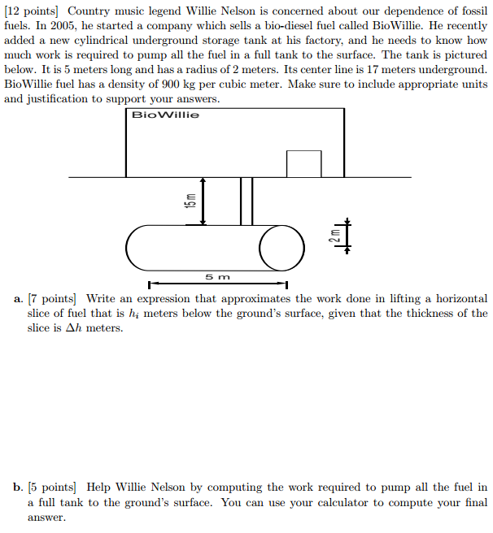

23.

Recall the quiz 2 problem. Now compute the work done in digging the hole.

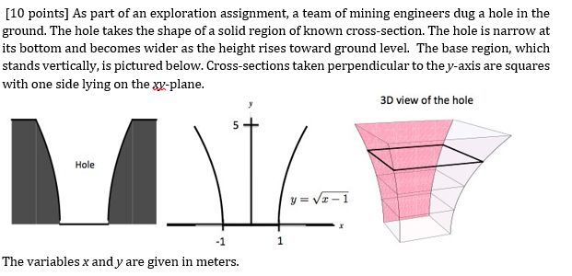

The density of the soil is 1600 kg

*The limits of my language are the limits of my world.*

- Wittgenstein, [**Tractatus Logico-Philosophicus**](http://en.wikipedia.org/wiki/Tractatus_Logico-Philosophicus)