**MATH 162 Practice QUIZ V**

1. For each improper integral (of the second kind) below, determine convergence or divergence. For those that converge, compute its value.









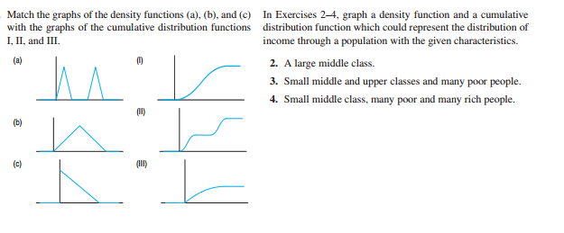

3. In each of the following two exercises, graph a density function and a cumulative distribution function which could represent the distribution of income through a population with the given characteristics.

1. A large middle class.
2. Small middle and upper classes and many poor people.
3. Small middle class, many poor and many rich people.

4. Find the *volume* of the solid of revolution obtained by rotating the curve

y = 1/x2 from x = 1 to x = ∞ about the x-axis or explain why no such number exists.

13.

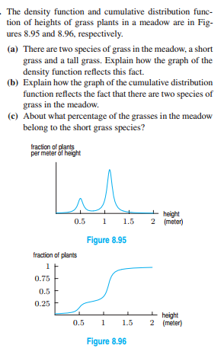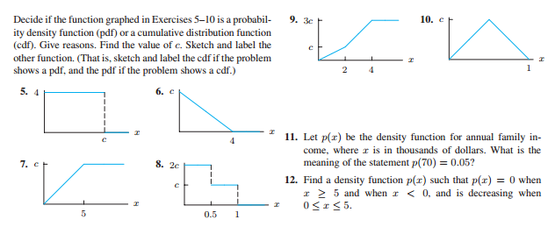

14. For each of the following improper integrals (of the second or third kind), determine convergence or divergence. As needed, use an appropriate version of the Comparison Test.

(a) 

(b) 

(c) 

(d) 

(e) 

(f) 

(g) 

15. For each of the following sequences, determine *convergence* or *divergence*. In the case of convergence, find the *limit* of the sequence. *Briefly explain your reasoning!*

(a) 

(b) 

(c) 

(d) 

(e) 

16. Consider the following *recursively defined* sequence:

a1 = 4

a2 = 2

an = an-1an-2 – an-1 – an-2 + 1 for n ≥ 3.

Find the numerical values of a3, a4, a5 and a6. (Show your work.)

*17. Why does an increasing sequence that is bounded above converge? Is there a similar result for decreasing sequences?*

*18. Does every bounded sequence converge? Can a convergent sequence have two limits?*

*19.* For n ≥ 1, let



Determine convergence or divergence of the sequence {an}. (*Hint:* Do *not* try to evaluate the integral! Calculator solutions are not accepted.)

*Hint*: Is the sequence *monotone*?

*20.* Let an = 1/1 + ½ + 1/3 + ¼ + … +1/n for n ≥ 1(integers only)

Demonstrate that the sequence {an} diverges.

21. Assuming that the limit exists, find it.



22. By computing the first few terms, guess what the limit of the following recursively defined sequence.



*There is more danger of numerical sequences continued indefinitely than of trees growing up to heaven. Each will some time reach its greatest height.*

- [Friedrich Ludwig Gottlob Frege](http://www.todayinsci.com/F/Frege_Friedrich/FregeFriedrich-Quotations.htm), **Grundgesetz der Arithmetik** (1893)