**MATH 162 (revised) Practice QUIZ VI**

1. For each of the following sequences, determine *convergence* or *divergence*. In the case of convergence, find the *limit* of the sequence. *Briefly explain your reasoning!*

(a) 

(b) 

(c) 

(d) 

(e) 

2. Consider the following *recursively defined* sequence:

a1 = 4

a2 = 2

an = an-1an-2 – an-1 – an-2 + 1 for n ≥ 3.

Find the numerical values of a3, a4, a5 and a6. (Show your work.)

3. To which of the following series does the “*nth term test for divergence*” apply? Explain!













*4.* For n ≥ 1, let



Determine convergence or divergence of the sequence {an}. (*Hint:* Do *not* try to evaluate the integral! Calculator solutions are not accepted.)

*Hint*: Is the sequence *monotone*?

*5.* Let an = 1/1 + ½ + 1/3 + ¼ + … +1/n for n ≥ 1(integers only)

Demonstrate that the sequence {an} diverges.

6. Assuming that the limit exists, find it.



7. By computing the first few terms, guess what the limit of the following recursively defined sequence.



**8.** Carefully state the **Comparison Test** for positive series.

**9.** For each of the following infinite series, determine *convergence* or *divergence. In the case of convergence, find the sum of the series:*



(b) 



(d)  (Hint: Calculate the first few partial sums.)

(e) 

(f) 0.123123123…

**10.**  For each sequence below, determine *convergence* or *divergence*. Justify your answers. Calculator results will not earn full credit.

(a) an = 

(b) bn = 

(c) cn = 

(d) dn = 

(e) en = 

(f) fn = 

(g) gn = 

**11.** (a) Use the comparison test to show that  converges. (*Hint:* Compare to the telescoping series . )

(b) What can you say about  where p 2? (Hint: *Compare* to )

(c) What can you say about  where p 1?

(*Hint:* Compare to )

12. Find the *sum* of each of the following convergent series. Show your work.

(a) 

(b) 

(c) 5.314314314314314…

13.

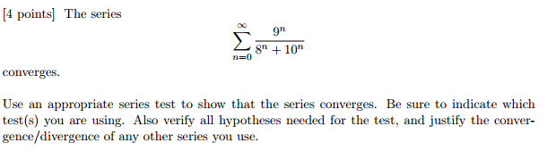

14. Does the following series converge or diverge? Justify.

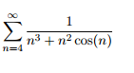

15.

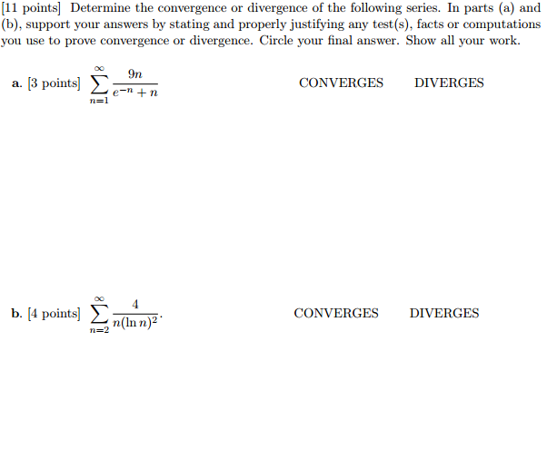

*There is more danger of numerical sequences continued indefinitely than of trees growing up to heaven. Each will some time reach its greatest height.*

- [Friedrich Ludwig Gottlob Frege](http://www.todayinsci.com/F/Frege_Friedrich/FregeFriedrich-Quotations.htm), **Grundgesetz der Arithmetik** (1893)