**MATH 162 Practice QUIZ VII**

1. For each numerical series below, determine *convergence* or *divergence*. In the case of convergence, determine if the series converges *absolutely* or *conditionally*. Justify each answer.

















2. For each of the following numerical series, determine if the series *diverges*, *converges conditionally* or *converges absolutely*. Justify your answers!

(a) 

(b) 

(c) 

(d) 

(e) 

(f) 

3. Does absolute convergence imply convergence? Does convergence imply absolute convergence? Why?

4. How many terms are required in order to estimate each of the following sums accurately to 4 decimal places?

1. 
2. 
3. 

5. For each of the following *power series*, determine the *interval of convergence*. Do not study end-point behavior.

(a) 

(b) 

(c) 

(d) 

(e) 

(f) 

6. *(University of Michigan final exam)*

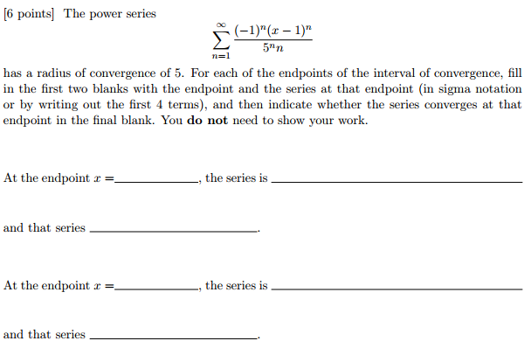

7. *(University of Michigan final exam)*

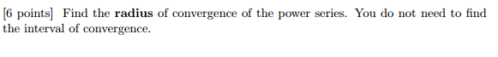 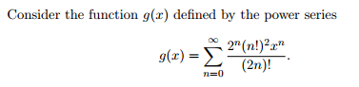

*Pure mathematics is, in its way, the poetry of logical ideas.*

- Albert Einstein