**MATH 162 Practice QUIZ VIII**

1. Find a power series expansion of 
2. For each of the following functions, find the 4th order Taylor polynomial centered at

x = *c* :

1. y = sinh x + 3 cosh x, c = 0
2. y = 1 + x + e3x, c = 0
3. y = 1/(x + 2), c = 0
4. y = ln(1 + x), c = 0
5. y = x1/2, c = 4
6. y = sin x, c = /4
7. y = 1 + x + 3x2 – 4x3, c = 0
8. y = 1 + x + 3x2 – 4x3, c = 1
9. y = xe2x, c = 0
10. Using multiplication of power series, find the *first four non-zero* terms of the Maclaurin series expansion of f(x) = e2x cos(3x).
11. Using division of power series, find the *first four non-zero* terms of the Maclaurin series expansion of



1. Using your choice of technique, find the *first four non-zero* terms of the Maclaurin series expansion of:
2. y = xe-4x
3. y = (2 + x)/(1 – x)
4. y = (1 – x – x2) e2x
5. y = (sin x) ln(1 + x)
6. y = x cos2 x
7. 
8. y = exp(1 + x2)
9. Find the Taylor series expansion of y = ex at x = c.
10. *(University of Michigan final exam problem)*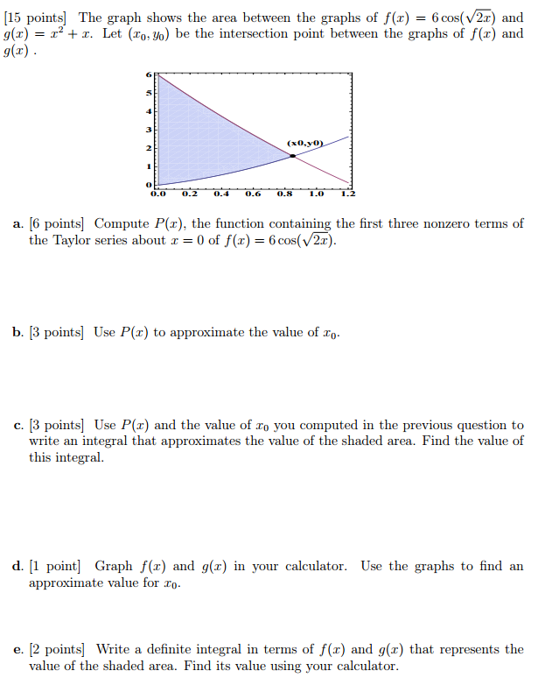
11. Without using L’Hôpital’s rule, find



1. By differentiating an appropriate power series, compute the following sum:



1. Find the Taylor series of



centered at x = -1.

1. Let F(x) = x4 arctan(3x). Find F(2345)(0).

*Hint:* Beginning with a geometric series, find the Maclaurin series expansion of arctan(t).

1. Without using L’Hôpital’s rule, find



1. Find the first four non-zero terms in the Maclaurin expansion of f(x) = tan x by dividing the series for sin x by the series for cos x.

*Problems from Stewart’s calculus:*

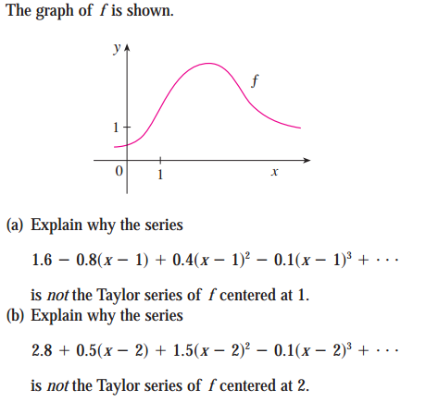

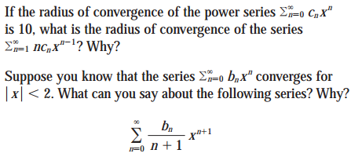

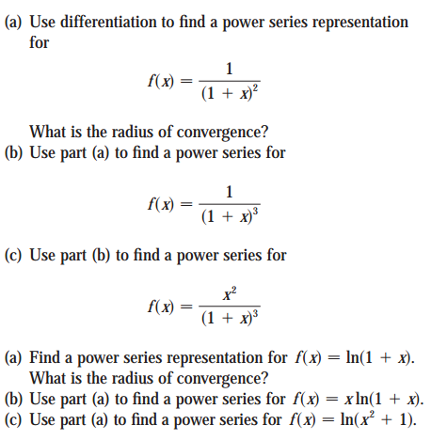

Find the *domain* of the Bessel function

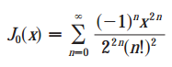

Show that the Bessel function



is a solution to the following differential equation.



*ne cannot escape the feeling that these mathematical formulas have an independent existence and an intelligence of their own, that they are wiser than we are, wiser even than their discoverers.*

- Heinrich Hertz