**MATH 162 Practice TEST 2-A**

1. Determine *convergence* or *divergence* of each of the following improper integrals:







1. For each of the following infinite series, determine *convergence* or *divergence. In the case of convergence, find the sum of the series:*



(b) 



(d) 

(e) 

(f) 0.123123123…

***3.*** *Evaluate* each of the following convergent improper integrals. Show your work!

(A) 

(B) 

4. For each of the following improper integrals, determine convergence or divergence. *Justify each answer! (That is, if you use the comparison test, exhibit the function that you choose to use for comparison and show why the appropriate inequality holds.)*

(A) 

(B) 

**5.**  For each given sequence, determine *convergence* or *divergence*. Justify your answers.

(a) an = 

(b) bn = 

(c) cn = 

(d) dn = 

(e) en = 

(f) fn = 

(g) gn = 

**6.** Find the *sum* of each of the following convergent series. Show your work.

(a) 

(b) 

(c) 5.314314314314314…

**7.** (a) Give an *example* of a numerical series that is *not positive* but which is *absolutely convergent.*

1. Give an example of a *conditionally convergent* numerical series.
2. Give an example of two *divergent* numerical series whose sum is *convergent.*

**8.**For each series below, determine convergence or divergence. Justify each answer.

(a) 

(b) 

(c) 

(d) 

(e) 



**9.** Consider the following recursively defined sequence:

c1 = 7, c2 = 4, and



(a) Find the values of *c3, c4* and *c5*.

(b) Assuming that the limit of *cn* (as n → ∞) exists, find its value.

**10**.  *(Show your work!)*

**11.** The series 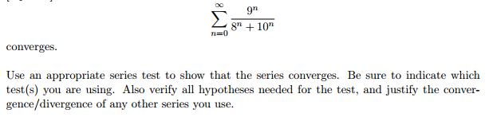

**12.** For each of the following improper integrals, determine convergence or divergence.

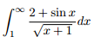





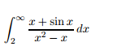

**13.** A machine produces copper wire, and occasionally there is a flaw at some point along the wire.The length x of the wire produced between two consecutive flaws is a continuous random variable with probability density function:



Show your work in order to receive full credit:

1. Find the value of *c*.
2. Find the *cumulative distribution function* P(x) of the density function f(x). Remember that a cumulative distribution function is defined on the entire real line.
3. Find the *expected value* of the length of wire between two consecutive flaws.



*"Can you do addition?" the White Queen asked. "What's one and one and one and one and one and one and one and one and one and one?" "I don't know," said Alice. "I lost count."*

- Lewis Carroll, **Through the Looking Glass**