**MATH 162 Practice TEST 2-b**

1. For each numerical series below, determine *convergence* or *divergence*. Justify each answer.

(a) 

(b) 

(c) 

(d) 

**2.** For each sequence below, determine convergence or divergence. *In the case of convergence, find the limit. Justify your answers.*

1. 

2. 

3. 

4. 

5. 

6. 

**3.**Consider the following recursively defined sequence:



(a) Find the values of *b2* and *b3*. (Express your answers to the nearest hundredth.)

(b) Assuming that the limit of *bn* as n → ∞ exists, find its value.

**4.** For each of the following improper integrals, determine convergence or divergence. *Justify each answer!*

1. 
2. 
3. 
4. 

**5.** *For each of the following sequences, determine convergence or divergence. In the case of convergence, find the limit of the sequence.*

(A) 

(B) 

(C) 

(D) 

(E) 

**6.** For each of the infinite series below, determine *convergence* or *divergence*. In the case of convergence, compute the sum of the series. Be certain to justify your answers!

(a) 

(b) 

(c) 

(d) 

(e) 

(f) 

(g) 0.04040404…

7. For each improper integral given below, determine *convergence* or *divergence*. *Justify your answers!*

(a) 

(b) 

(c) 

(d) 

(e) 

(f) 

8. For each improper integral given below, determine *convergence* or *divergence*. (You will need to use the Comparison Test here.) *Justify your answers!*

(a) 

(b) 

(c) 

(d) 

9. Find the *volume* of the solid of revolution obtained by rotating the curve y = 1/(1 + x2)1/2 from x = 0 to x = ∞ about the x-axis or explain why no such number exists.

10. Consider the harmonic series .

(a) *Without* using calculus, prove that this series diverges.

(b) Using the Integral Test, prove that this series diverges.

**11**. In March of 2015 it was announced that, “[after six years of planetary observations, scientists at NASA say they have found convincing new evidence that ancient Mars had an ocean](http://www.nytimes.com/2015/03/06/science/mars-had-an-ocean-scientists-say-pointing-to-new-data.html?_r=0).” According to the New York Times report, “it was probably the size of the Arctic Ocean”, larger than previously estimated, the researchers reported on Thursday. “The body of water spread across the low-lying plain of the planet’s northern hemisphere for millions of years”, they said.

Professor Albertine at Caltech has developed a new theory about these ancient sea beds of Mars. She believes that 3.8 billion years ago there was a huge population of eels living in this Martian ocean. In her model, the length of an eel is given by the probability density function



where *x* is measured in meters and *k* is a positive constant.

1. Determine the value of the constant *k* for which f(t) is in fact a probability density function.
2. Determine the probability that a Martian eel was *longer* than 1 meter.
3. Determine the probability that a Martian eel was *less than* 2 meters in length.
4. Find the *expected value* of the length of a Martian eel.
5. Find the *median* of the eel’s length.

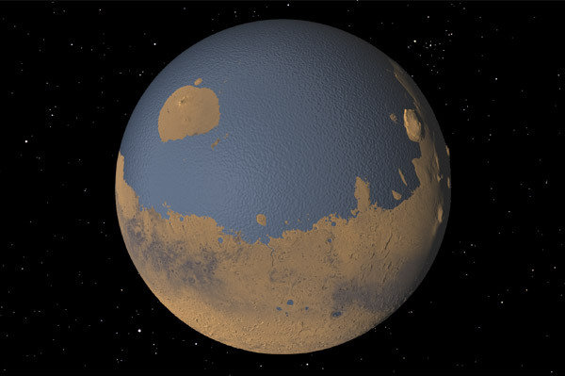

An artist rendering of what recent research suggests Mars might have looked like around 4 billion years ago, when most researchers think the planet was considerably warmer than it is today. CreditGreg Shirah/NASA

***12****.* Consider the graph below depicting four functions for x> 0. The only point of intersection between any two of the functions is at x = 1. The functions f(x) and g(x) are both differentiable, and they each have y = 0 as a horizontal asymptote and x = 0 as a vertical asymptote.

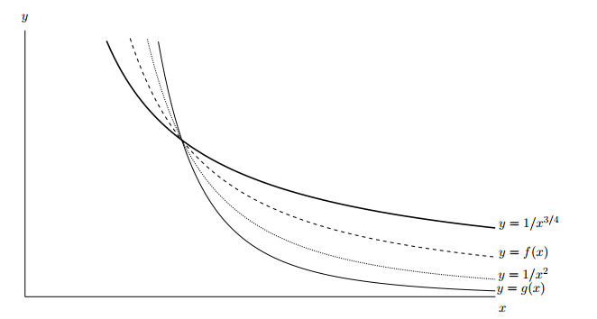

Use the graph to determine whether the following quantities converge and diverge. If there is not enough information to determine convergence or divergence, write “Not enough information.” Explain your reasoning.









*(e)* The volume of the solid formed by rotating the region between f(x) and the x-axis from x = 1 to x = about the x-axis.

**Extra credit:**

For which values of *p* and *q* does the following improper integral converge?



*My New Zoo, McGrew Zoo, will make people talk.*

*My New Zoo, McGrew Zoo, will make people gawk*

*At the strangest odd creatures that ever did walk.*

*I'll get, for my zoo, a new sort-of-a hen*

*Who roosts in another hen's topknot, and then*

*Another one roosts in the topknot of his,*

*And another in his, and another in HIS,*

*And so forth and upward and onward, gee whiz?*

- Dr. Seuss, **If I Ran the Zoo**