**MATH 162 Practice TEST III**

1. **(Review)** For each of the following infinite series, determine *convergence* or *divergence. In the case of convergence, find the sum of the series:*



(b) 



(d) 

(e) 

(f) 0.123123123…

**2.**For each series below, determine absolute convergence, conditional convergence or divergence. Justify each answer.











**3.** For each power series below, determine the *radius of convergence* and the *interval of convergence*. Study the behavior of each power series at the *endpoints*.



(b) 

(c) 

**4.**(a) Find the 3rd order Maclaurin polynomial of *cosh x*.

(b) Find the 5th order Taylor polynomial of *cos x* centered at x = /2.

**5**. Find the 4th order Taylor polynomial of ex centered at x = 2.

**6**. Find the 3rd order Maclaurin polynomial of

f(x) = 4 + (x+13)2 + (x+13)3

**7.** By differentiating the power series expansion of y = 1/(1 – x), find the value of



**8**. Find the *first five* non-zero terms of the Maclaurin series expansion of

h(x) = (1 + 2x2) e3x.

**9**. Let f(x) = x8 e5x. Compute f(100)(0). Do not simplify your answer.

***10.*** Find the *radius of convergence* of the power series:



***11.*** Find the *radius of convergence* of the power series:



***12.*** Find the *radius of convergence* of the power series:



**13 .** *Without using* l'Hôpital's rule, calculate the following limit. Show your work!



14. Let G(x) = x3 cosh (3x). Using an appropriate Maclaurin series, compute G(2017)(0). (Do not try to simplify your answer.)

15. Find the first four non-zero terms of the Maclaurin series for each of the following:







16. (a) Express  as a complex number of the form a + bi.

(b) By expressing -1 as an appropriate complex power of *e*, calculate the five fifth roots of -*i*.

Express your answers in the form a + bi.

(c) Using Euler’s formula, express cos(4x) in terms of cos x and sin x.

17. Using division of power series, find the first three non-zero terms of the Maclaurin series expansion of



18. Using multiplication of power series, find the first four non-zero terms of the Maclaurin series expansion of



19. Determine the *interval of convergence* of the following power series. (You need not study end-point behavior.)



20. Analyze the behavior of the series



21. Prove Euler’s formula.

22. What is the relationship between cosh x and cos x? between sinh x and sin x?

23*. [University of Michigan final exam question]* The graph shows the area between the graphs of f(x) = 6 cos and g(x) = x2 + x. Let (x0, y0) be the intersection point between the graphs of f(x) and g(x).

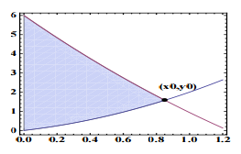

(a) Compute P(x), the function containing the first three nonzero terms of the Taylor series about x = 0 of f(x) = 6 cos.

(b) Use P(x) to approximate the value of x0.

(c) Use P(x) and the value of x0 you computed in the previous question to write an integral that approximates the value of the shaded area. Find the

1. (d) Graph f(x) and g(x) in Wolfram Alpha or your calculator. Use the graphs to find an approximate value for x0.

(e) Write a definite integral in terms of f(x) and g(x) that represents the value of the shaded area. Find its value using your Wolfram Alpha or your calculator.

24.  *[University of Michigan final exam question]* (a) Find the Maclaurin series of sin(x2). Your answer should include a formula for the general term in the series.

(b) Let *m* be a positive integer, find the Maclaurin series of cos(mπx). Your answer should include a formula for the general term in the series.

(c) Use the second degree Maclaurin polynomials of sin(x2) and cos(mπx) to approximate the value of bm, where



(The number bm is called a *Fourier coefficient of the function sin( x2 ).* These numbers play a key role in Fourier analysis, a subject with widespread applications in engineering and the sciences.)

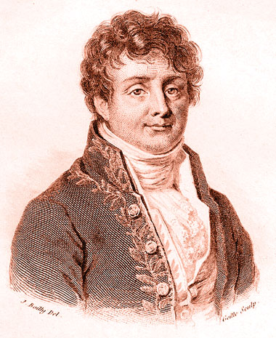

Jean-Baptiste Joseph Fourier (1768 – 1830)