MATH 162 Solutions: Quiz 1

1. *[5 pts]* Express the area under *one arch* of the curve y = 3 cos 5x as a Riemann (i.e. definite) integral. No need to evaluate this integral. *Sketch!*

*Solution: First note that the period of cos 5x is (1/5)(period of cos x) = 2/5.*



*So the area that we seek may be obtained by integrating from x = -2/5 to 2/5.*

**

1. *[5 pts]* Using the *Fundamental Theorem of Calculus*, compute the derivative of the function



*Solution: Employing the FTC, we find*



1. *[5 pts]* Evaluate



*Solution:*

*Since y = |4 – x| is piecewise linear, we can easily sketch its graph:*



*Note that the area under this curve over [3, 4] is simply the area of a triangle, ½ (1)(1) = ½ and the area under this cruve over [4, 6] is again the area of a triangle, ½ (2)(2) = 2. Thus the area under this curve over [3, 6] is ½ + 2 = 5/2.*

4. *[5 pts]* Using the method of *judicious guessing* or *substitution*, evaluate



*Solution: Let our first guess be g1(x) = (3 + 2 sin x)3/2.*

*Now dg1 /dx = (3/2) (3 + 2 sin x)1/2 (0 + 2(1/3 cos x), we see how to modify g1 to obtain the correct anti-derivative:*

*g2(x) = (1/3) g1(x) = (1/3)(3 + 2 sin x)3/2 . Hence*



# *[5 pts]* Find:

# 

# *Solution: Since both the numerator and denominator tend towards 0 as x 0, we may apply l’Hopital’s rule:*

# 

# *Here we have applied l’Hopital’s rule a second time since both ex – 1 and 2x tend toward 0 as x 0.*

# *[5 pts]* Suppose *f*(*x*) is a function with the following properties:

|  |  |
| --- | --- |
| * *f*(0) = 4 * *f*(2) = 0 | * *f*(*x*) is decreasing on [0*,* 2] * *f*(*x*) is concave down on [0*,* 2] |

Suppose that 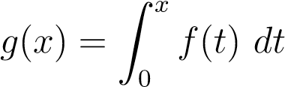.

* 1. Is *g*(*x*) increasing or decreasing on [0*,* 2]? No explanation necessary.

*Solution: Using the FTC, we find dg/dt = f(t) > 0.*

*Thus g is increasing on [0, 2].*

* 1. Is *g*(*x*) concave up or concave down on [0*,* 2]? No explanation necessary.

*Solution: Assuming that f is differentiable on (0, 2),*

*d2g/dt2(g) = d/dt (dg/dt) = d/dt (f(t)) < 0 since we are given that f is decreasing on*

*[0, 2]. We conclude that g is concave down on [0, 2].*

* 1. Sketch a graph of *f*(*x*) which satisfies the above conditions and use it to explain why

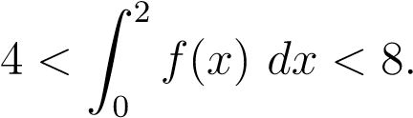

*Solution:*



*Since the area beneath f(x) above [0, 2] must be strictly smaller than the area of the rectangle with height 4 and width 2, we obtain: *

*Since f(x) lies above the line joining (0, 4) and (2, 0), the area beneath f(x) above*

*[0, 2] must be strictly larger than the area of the right triangle with vertices (0, 0),*

*(0, 4) and (2, 0). Since the area of this triangle is ½ (2)(4) = 4, we obtain: *