**MATH 162 Solutions: QUIZ II**

1. *[20 pts]* Consider the region R in the first quadrant that is bounded by the curves y = x2 and

y = . Sketch this region!



This region is rotated about the axis x = 2 to create a solid.

1. Using the *shell method* write the volume of this solid of revolution as a Riemann integral.

Show your work. Do not evaluate.

*Solution: We choose a vertical rectangle by fixing x, where 0 x 1. Rotating this rectangle about the axis x = 2, we obtain a shell of height $\sqrt{x}-x^{2}$ and of radius 2 – x. Thus the shell will have area = 2  r h = 2  (2 – x). The thickness of the “label” (shell) is x.*

*Thus the volume of the shell is 2  (2 – x) x.*

*Summing, we obtain*

**

1. Using the *washer method* write the volume of this solid of revolution as a Riemann integral.

Show your work. Do not evaluate.



*Solution: Here we need a horizontal rectangle since the washer method requires that the rectangle be perpendicular to the axis of rotation. To select a rectangle we specify y, where 0 y 1. Now the outer radius of the washer is the horizontal distance from the upper curve to the axis x = 2. This is 2 – y2. Next, the inner radius of the washer is the horizontal distance from the lower curve to the axis x = 2. This distance is 2 – $\sqrt{y}$. Now let the thickness of the washer be y.*

*Hence the volume of the washer is ( rout2 –  rin2* ) *y = ( (2 – y2)2 –  (2 – 2* ) *y*

*Summing these values yields*



1. *[13 points]* As part of an exploration assignment, a team of mining engineers dug a hole in the ground. The hole takes the shape of a solid region of known cross-section. The base region, which stands vertically, is pictured below. Cross-sections taken perpendicular to the *y*-axis are squares with one side lying on the *xy*-plane.

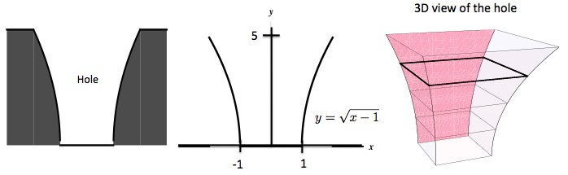

The variables *x* and *y* are given in meters.

Take a slice of soil of thickness ∆*y* meters located at *y* meters above bottom of the hole. Write a Riemann integral that represents the volume of the hole. Show all work to receive full credit.

*Solution: Let y be a point on the y-axis between 0 and 5 that determines a slice of soil of thickness y that is y meters above the bottom of the hole. Then the area of the square cross-section is*

*(2y2 + 2)2. Hence the volume of this square slice is:*

*V =FSlice  = (2(y2 + 1))2 y*

*Thus*

1. *[20 points]* Consider the region in the *xy*-plane bounded by the curves *y* = 9 − *x*2*, x* = 1*,* and *y* = 5. This region is pictured below.

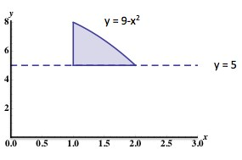

Using the disk, washer or shell method (your choice!) write a Riemann integral that represents each of the following quantities. Do not evaluate.

1. The volume of the solid obtained by rotating the region about the *y*-axis.

*Solution:*

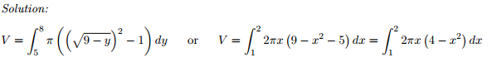

1. The volume of the solid obtained by rotating the region about the line *y* = 5

*Solution:*

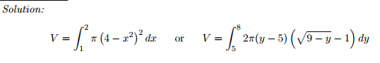

*The book of nature is written in the language of mathematics.*

- Galileo