**MATH 162 Solutions: QUIZ VI**

1. *[10 pts]* Find a formula for the general term *an* of each sequence below. Assume the pattern of the first few terms continues, and that the first term in each sequence corresponds to *n* = 1. For example, in part(a), *a*1 = 5.
   1. 5*,* 8*,* 11*,* 14*,* 17*, ...*

This sequence grows linearly: that is, the next term is 3 greater than the current term.

*an = 5 + 3(n – 1)*

$-3, 2, -\frac{4}{3}, \frac{8}{9}, -\frac{16}{27},…$

This sequence grows geometrically: that is, the next term is (-2/3) times the current term.

*an = 3(-1)n(2/3)n – 1*

1. *[10 pts]* Let $a_{n}=\frac{2n}{3n+1}$
   1. Determine whether the sequence {*an*} is convergent or not. If the sequence converges, find its limit. If the sequence diverges, explain why. *(Show your work.)*

*Solution: We conjecture that {an} converges to 2/3. Toward this end:*

* 1. Determine whether the series  is convergent or not.

*Justify* your answer!

*Solution:* The series  diverges since the sequence of atoms does not converge to 0. (nth term Test for Divergence)

1. *[28 pts]* For each of the following, determine whether the series is *convergent* or *divergent*. If the series *converges*, find the *sum*. If the series *diverges, explain why.*

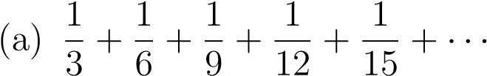

*Solution: This series diverges since it equals 1/3 times the harmonic series:*

*Than is: *

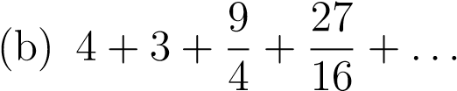

*Solution: Since an+1 / an = ¾, we recognize this series as geometric with R = ¾.*

*Since |R| < 1, this series converges to:*

**

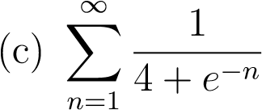

*Solution: This series diverges because of the nth term Test for Divergence.*

**

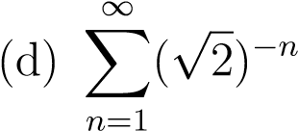

*Solution: This series converges because it is geometric with common ratio of*

**

The sum of this series is **

1. *[30 pts]* Using an appropriate comparison test, determine whether each of the following series converges or diverges. *Explain your reasoning clearly.*

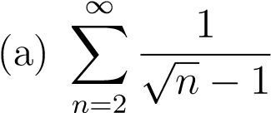

*Solution: We know from the (“partial” )p-test that*  diverges. Hence we will try to show that the given series diverges:

Toward this end: 

Finally, since  diverges, the Comparison Test allows us to conclude that the original series diverges as well.



*Solution: Since  converges since it is geometric with common ratio of ½, we conjecture that our original series converges as well. Towards this end:*

**

*Thus, since the geometric series  converges, our original series must converge as well.*

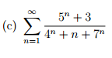

*Solution: *

*Note that the denominator is dominated by 7n --------* ***not 11n***

*Since an is roughly 5n / 7n = (5/7)n, we conjecture that the original series converges.*

*Now: *

*Since is a convergent geometric series (with common ration of 5/7), we may invoke the comparison theorem to conclude that*

1. The *factorial*, *n*!, of a positive integer *n* is defined to be

*n*! = *n* · (*n* − 1) · (*n* − 2)···3 · 2 · 1. For example, 5! = 5 · 4 · 3 · 2 · 1 = 120.



* 1. *[10 pts]* Find the partial sums *s*1, *s*2, *s*3, and *s*4 of this series. *Write each of the four partial sums as a single fraction in lowest terms.*

*Solution: Using the definition of partial sum, we have:*

*s1 = a1 = 1/(2!) = ½*

*s2 = s1 + a2 = ½ + 2/(3!) = ½ + 1/3 = 5/6*

*s3 = s2 + a3 = 5/6 + 3/(4!) = 5/6 + 1/8 = 23/24*

*s4 = s3 + a4 = 23/24 + a4 = 23/24 + 4/(5!) = 23/24 + 1/30 = 119/120*

* 1. *[5 pts]* Use your answers to part (a) to infer a general formula for *sn*. (You do not have to verify your answer.)

*Solution: We infer from the pattern above that*

**

* 1. *[4 pts]* Use your answer in part (b) to find the *sum of the series*.

*Solution: *

*As a net is made up of a series of ties, so everything in this world is connected by a series of ties. If anyone thinks that the mesh of a net is an independent, isolated thing, he is mistaken. It is called a net because it is made up of a series of interconnected meshes, and each mesh has its place and responsibility in relation to the other meshes.*

- Buddha

