Recall that the Taylor Series for a function *f*(*x*) centered at *x* = *a* is

 *.*

The Taylor Series centered at *a* = 0 is called the Maclaurin Series and it has the form



The Maclaurin Series for some familiar functions are given below along with their radii of convergence.

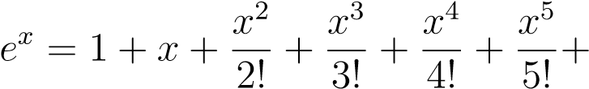 *R* = ∞

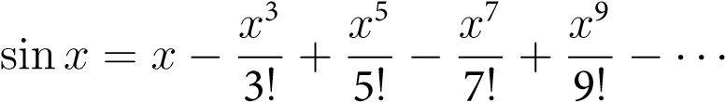 *R* = ∞

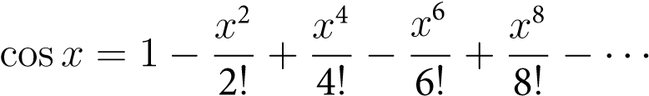 *R* = ∞

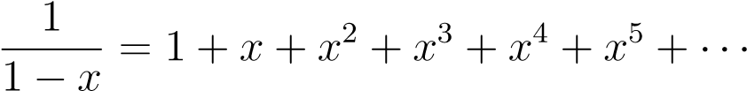 *R* = 1

**MATH 162– Solutions: Quiz 8**

For each of the following functions *f*(*x*) and centers *x* = *a*, find the first four non-zero terms of the Taylor series and the radius of convergence.

* 1. *f*(*x*) = *xe*2*x* centered at *x* = 0

Solution:  converges for all x.

Replacing x by 2x in the above, we have

 also converges for all x.

Finally, f(x) = x

The first four non-zero terms of this series are:



The series converges for all x.

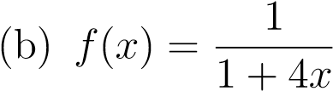 centered at *x* = 0

Solution: The geometric series  converges for all r, 0<r<1.

Replacing r by –4x we obtain



As we have replaced r by 4x, our new series will converge for |4x| < 1, that is: |x| < ¼

So the radius of convergence is R = ¼ .

1. Use the definition of the Taylor series to find the first five non-zero terms of the series for *f*(*x*) = ln *x* centered at *x* = 1

Solution: Computing the first 5 derivatives of f:

f(x) = ln x

f’(x) = 1/x

f’’(x) = -1/x2

f’’’(x) = 1/x3

f’(4)(x) = -1/x4

f’(5)(x) = 1/x5

Replacing x by 1:

f(1) = ln 1 = 0

f ’(1) = 1

f ’’(1) = -1

f ’’’(1) = 1

f’(4)(1) = -1

f’(5)(1) = 1

Thus the first five non-zero terms are:



1. Find the limit using Taylor series. Do not use l’Hˆopital’s Rule.

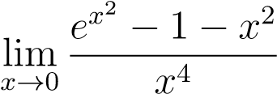

Solution:  converges for all x.

Substituting x2 for x in the above, we have

 also converges for all x. Hence



1. Find the exact value of the series

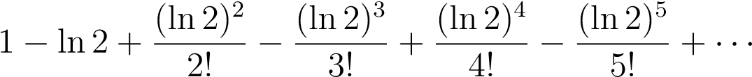

Solution: Since  replacing *x* by *–x*,



Thus 

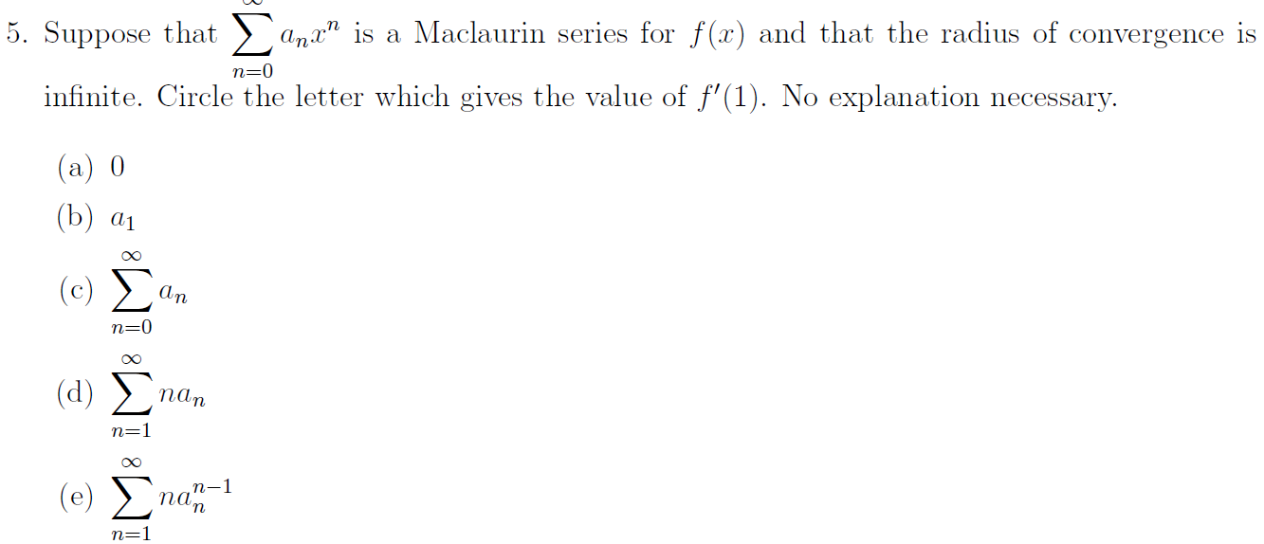

Solution:



Thusand so the correct choice is (e).

1. The Taylor series for *f*(*x*) centered at *x* = 1 is given by

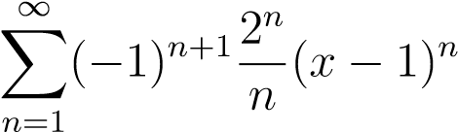.

* 1. Find the first four non-zero terms of the Taylor series for *f ’*(*x*) centered at *x* = 1.

Solution: We can write out the first several terms, or differentiate the general term.



Writing the first four non-zero terms of f ‘(x) centered about x = 1:



* 1. The Taylor series for *f*0(*x*) you found in part (a) is a geometric series. What is the common ratio of this geometric series?

Solution: The ratio between successive terms is: -2(x – 1)