Recommended websites

- Zombies & Calculus, http://www.pbslearningmedia.org/resource/nvnd-math-zombiecalc1/zombies-and-calculus-part-1/
- Zombies & Calculus, http://www.pbslearningmedia.org/resource/nvnd-math-zombiecalc2/zombies-and-calculus-part-2/
- MIT open courseware 18.01, http://ocw.mit.edu/courses/mathematics/18-01-single-variable-calculus-fall-2006/video-lectures/
- Calculus test banks: University of Michigan; Washington University St. Louis; University of Washington;

Recommended Texts

- Tom Apostol, Calculus, volume 1: One-Variable Calculus with an introduction to Linear Algebra, 2nd edition, Wiley (1967)
- J. Marsden & A. Weinstein, Calculus I (Undergraduate Texts in Mathematics), Springer-Verlag (1985)
- McCallum, Hughes-Hallett, Gleason, et al, Calculus, 6th edition, Wiley (2012)
- Larson & Edwards, Calculus, 9th edition, Brooks/Cole (2009)
- G. Simmons, Calculus with Analytic Geometry, 2nd edition, McGraw-Hill Science/Engineering/Math (1996)

Lighter reading
- Adams, Colin, Zombies and Calculus, Princeton University Press (2014)
- Adams, Hass, Thompson, How to Ace Calculus, The Streetwise Guide, Freeman (2003)
- Jason Bardi, Calculus Wars, Thunder’s Mouth Press (2006)
- Petr Beckmann, History of π, St. Martin’s Press (1971)
- David Berlinski, Tour of the Calculus, Vintage Books (1995)
- Sergiy Klymchuk, Counterexamples in Calculus, MAA (2010)
- Sergiy Klymchuk and Susan Staples, Paradoxes and Sophisms in Calculus, MAA (2013)
- Eli Maor, The Facts on File Calculus Handbook, Facts on File Science Handbooks (2003)
- Eli Maor, To Infinity and Beyond, Princeton University Press (1991)
- ed. James Newman, The World of Mathematics, 4-volumes, reprinted by Dover Publications (2003)
- George F. Simmons, Calculus Gems, MAA (2007)

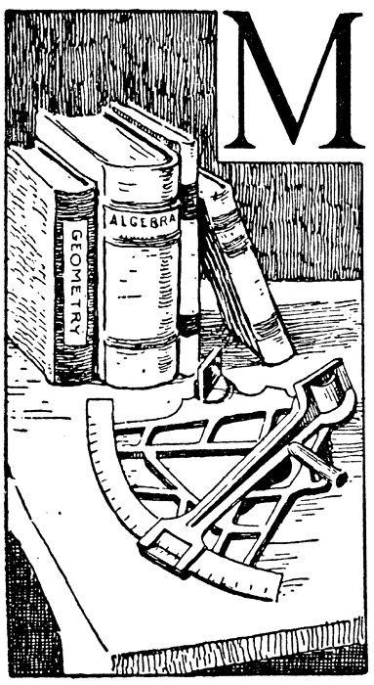
Course Home Page Department Home Page Loyola Home Page

