Math 116 — Final Exam
April 2011
Name:
Instructor:
Section:
- Do not open this exam until you are told to do so.
- This exam has 12 pages including this cover. There are 10 problems. Note that the problemsare not of equal difficulty, so you may want to skip over and return to a problem on which you are stuck.
- Do not separate the pages of this exam. If they do become separated, write your name onevery page and point this out to your instructor when you hand in the exam.
- Please read the instructions for each individual problem carefully. One of the skills beingtested on this exam is your ability to interpret mathematical questions, so instructors will not answer questions about exam problems during the exam.
- Show an appropriate amount of work (including appropriate explanation) for each problem,so that graders can see not only your answer but how you obtained it. Include units in your answer where that is appropriate.
- You may use any calculator except a TI-92 (or other calculator with a full alphanumerickeypad). However, you must show work for any calculation which we have learned how to do in this course. You are also allowed two sides of a 3⁰⁰ × 5⁰⁰ note card.
- If you use graphs or tables to find an answer, be sure to include an explanation and sketchof the graph, and to write out the entries of the table that you use.
- Turn off all cell phones and pagers, and remove all headphones.

Problem | Points | Score
1 | 10
2 | 7
3 | 8
4 | 8
5 | 14
6 | 9
7 | 12
8 | 13
9 | 9
10 | 10
Total | 100
You may find the following expressions useful. And you may not. But you may use them if they prove useful.
“Known” Taylor series (all around x = 0):
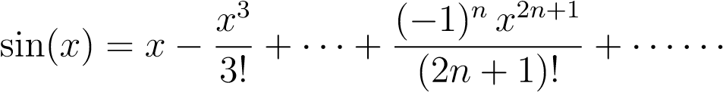 for all values of x
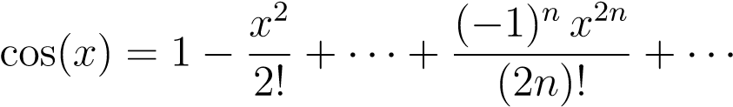 for all values of x
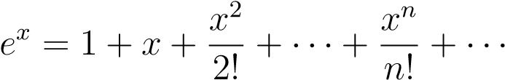 for all values of x
for −1 < x < 1
for −1 < x < 1
- [10 points] For each question, circle if the statement is always true or false. No justification is necessary.
    - [2 points] If lim_{n→∞} a_{n} = lim_{n→∞} b_{n} and 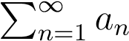 converges, then 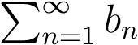 converges.
True False
    - [2 points] If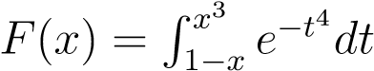 then F(x) is increasing.
True False c. [2 points]
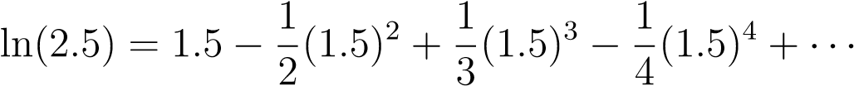
True | False
    - [2 points] The left graph is a probability density function for the height of clouds in the sky. A gust of wind causes all clouds higher than 2000 meters to rise an additional 500 meters. The right graph shows the heights of clouds afterwards. The median cloud height after the wind is 500/4 meters higher than the median cloud height before the wind.
True False
frac. of clouds / m Area =frac. of clouds / m Area =
m
Area=
1
4
2000
3000
m
Area=
1
4
2000
3500
    - [2 points] A particle’s position is given by the parametric equations (x(t),y(t)). If the graphs of x(t) and y(t) are given below, then the particle passes through the origin twice for 0 ≤ t ≤ 3.
xHtL yHtL
1
2
3
t
1
2
3
t
True False
- [7 points] For n ≥ 1, consider the following sequences
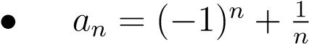.
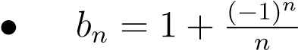.
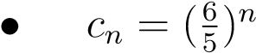.
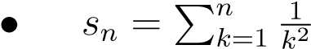.
Circle your answers. No justification is needed.
1. | Which sequences are bounded? | a_{n} | b_{n} | c_{n} | s_{n} | None.
2. | Which sequences are increasing? | a_{n} | b_{n} | c_{n} | s_{n} | None.
3. | Which sequences are convergent? | a_{n} | b_{n} | c_{n} | s_{n} | None.

- [8 points] Let
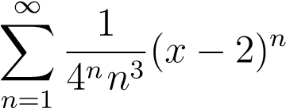
Find the interval of convergence of the power series. Justify your answer.
- [8 points] You are trapped on an island, and decide to build a signal fire to alert passing ships. You start the fire with 200 pounds of wood. During the course of a day, 40% of the wood pile burns away (so 60% remains). At the end of each day, you add another 200 pounds of wood to the pile. Let W_{i} denote the weight of the wood pile immediately after adding the i^{th} load of wood (the initial 200-pound pile counts as the first load).
    - [3 points] Find expressions for W₁, W₂ and W₃.
    - [3 points] Find a closed form expression for W_{n} (a closed form expression means that your answer should not contain a large summation).
    - [2 points] Instead of starting with 200 pounds of wood and adding 200 pounds every day, you decide to start with P pounds of wood and add P pounds every day. If you plan to continue the fire indefinitely, determine the largest value of P for which the weight of the wood pile will never exceed 1000 pounds.
- [14 points] Years later, after being rescued from the island, you design a machine that will automatically feed wood into a fire at a constant rate of 500 pounds per day. At the same time, as it burns, the weight of the wood pile (in pounds) decreases at a rate (in pounds/day) proportional to the current weight with constant of proportionality.
    - [3 points] Let W(t) be the weight of the wood pile t days after you start the machine. Write a differential equation satisfied by W(t).
    - [4 points] Find all equilibrium solutions to the differential equation in part (a). For each equilibrium solution, determine whether it is stable or unstable, and give a practical interpretation of its stability in terms of the weight of the wood pile as t → ∞.
    - [7 points] Solve the differential equation from part (a), assuming that the wood pile weighs 200 pounds when you start the machine.
- [9 points] The probability density function for the time t (in minutes) it takes for a pizza deliveryman to deliver a pizza is
p(t) = p0te−λt3
This does not include the time required to prepare the pizza, only the time required to deliver it.
    - [4 points] Find a formula for the mean of p(t) in terms of p₀ and λ. Your final answer should not contain any integrals.
    - [3 points] The pizza parlor advertises that if you don’t receive your pizza in 30 minutes or less after you order, then your pizza is free. After your order is taken, it takes 10 minutes for the chef to prepare a pizza for delivery. Write an expression for the probability that the next pizza that gets delivered will be free.
    - [1 point] If P(t) is the cumulative distribution of p(t), find an expression for P(20).
    - [1 point] Explain the practical meaning of the number P(20).
- [12 points]
    - [5 points] You rotate the region shown about the y-axis to create a drinking glass. Write an expression that represents the volume of material required to construct the drinking glass (your answer may contain f(y)).
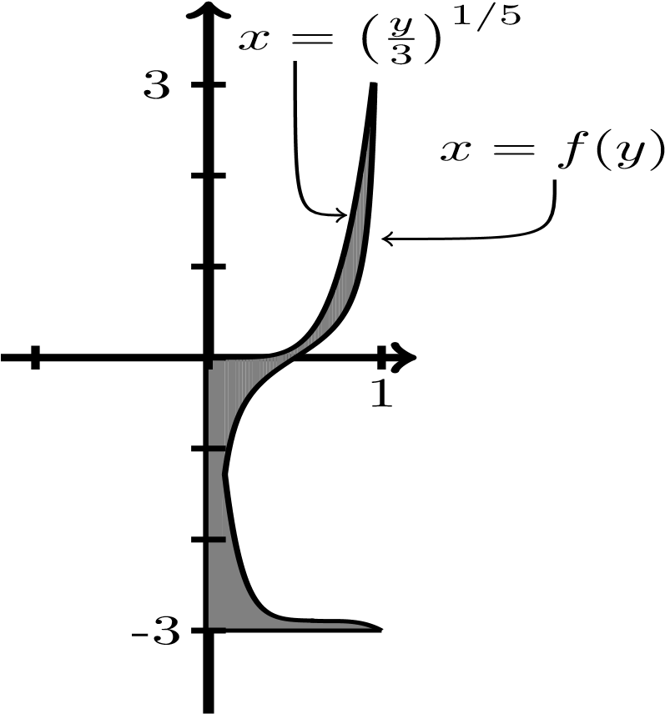
    - [7 points] Consider the vessel shown below. It is filled to a depth of 1 foot of water. Write an integral in terms of y (the distance in ft from the bottom of the vessel) for the work required to pump all the water to the top of the vessel. Water weighs
62.4 lbs/ft³.
1
ft.
y
2
ft.
5
ft.
3
ft.
- [13 points] A lamp is at the border of a small lagoon. The picture below shows the lamp at the origin and the lagoon described by the polar curve r = f(θ). During the night, the lamp illuminates the shaded region on the lagoon shown below.
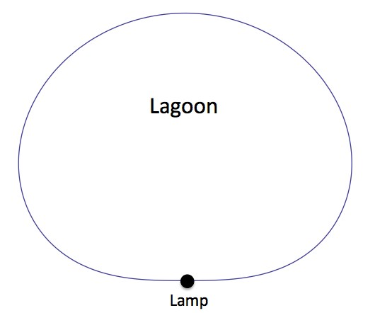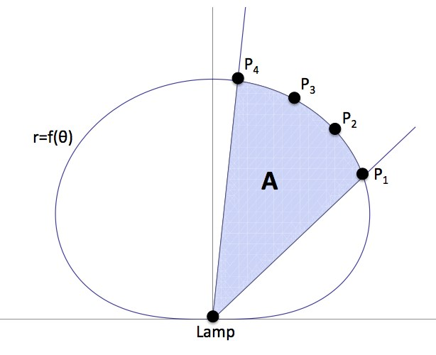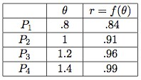
    - [3 points] If A is the shaded area shown above, then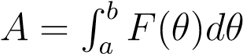 where
F(θ) = a = b = .
    - [5 points] Fill the table below with the values of F(θ). Then approximate the area of the shaded region using Left(3). Write all the terms in your sum.
θ | .8 | 1 | 1.2 | 1.4
F(θ)
    - [1 point] Is F(θ) increasing, decreasing or neither?
    - [1 point] Is F(θ) concave up, concave down or neither?
    - [3 points] Which Riemann sums (Left(3), Right(3) and/or Trap(3)) yield an underestimate of the shaded area?
- [9 points]
    - [2 points] Find the Taylor series about x = 0 of sin(x²). Your answer should include a formula for the general term in the series.
    - [2 points] Let m be a positive integer, find the Taylor series about x = 0 of cos(mπx). Your answer should include a formula for the general term in the series.
    - [5 points] Use the second degree Taylor polynomials of sin(x²) and cos(mπx) to approximate the value of b_{m}, where
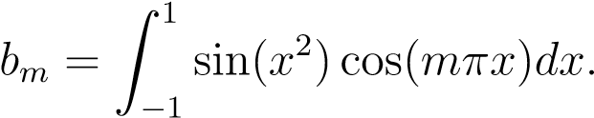
(The number b_{m} is called a Fourier coefficient of the function sinx². These numbers play a key role in Fourier analysis, a subject with widespread applications in engineering and the sciences.)
- [10 points]
    - [5 points] Determine whether the following series converge or diverge (circle your answer). For each, justify your answer by writing what convergence rule or convergence test you would use to prove your answer. If you use the comparison test or limit comparison test, also write an appropriate comparison function. 1.[2 points]
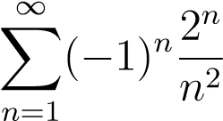 Converge Diverge
2.[3 points]
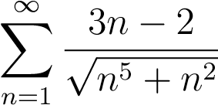 Converge Diverge
    - [5 points] Does the following series converge conditionally, absolutely, diverge or is it not possible to decide? Justify.
