Worksheets: MATH 162
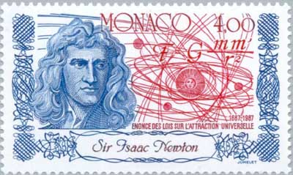

Worksheet I: review
Worksheet II: volume
Worksheet III: washers/disks vs shells
Worksheet IV: parameterized curves
Worksheet V: arc length, surface area, work
Worksheet VI: integration by parts
Worksheet VII: hyperbolic functions
Worksheet VIII: little o and big O
Worksheet IX: improper integrals
Worksheet X: probability
Worksheet XI: sequences
Worksheet XII: numerical series
Worksheet XIII: integral, ratio, root tests
Worksheet XIV: absolute & conditional convergence
Worksheet XV: power series

Work! God wills it. That, it seems to me, is clear.
- Gustave Flaubert (letter to Louise Colet (1845)
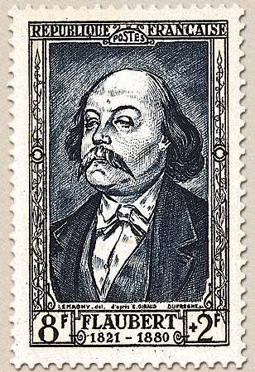

Course Home Page Department Home Page Loyola Home Page

