WORKSHEET X
Applications of Improper Integrals to Probability and Physics

- Suppose a species of bacteria typically lives 4 to 6 hours. Assume that the probability density function f(x) of the time of death is uniform on [4, 6]. This means that fhe pdf is given by:
- Find the value of the constant c.
- What is the probability that a bacterium lives exactly 5 hours?
- What is the probability that the bacterium dies between 5 hours and 5.01 hours?
- What is the probability that the bacterium dies between 5 hours and 5.001 hours?
- What is the probability that a bacterium lives longer that 5 hours? 5.5 hours? 6 hours?

- The phones offered by the Last Chance to Save Phone Network have some chance of failure after they are activated. Suppose that the density function p(t) describing the time t in years that one of their phones will fail is

  - Verify that p(t) is indeed a probability density function.
  - Find the cumulative distribution function P(t) of p(t).
  - If the probability of a cell phone failing within a year and a half is , find the value of λ.
  - The Last Chance to Save Phone Network offers its clients a replacement phone after two years if they sign a new contract. What is the probability that the client will not have to replace his or her phone before the company will give him or her a new one?
  - Find the mean (expected value) of failure.

- In the late 29th century, Mom’s Friendly Robot Company is the main global robot manufacturing company. The Albertine Unit 13 model is designed to contain a backup unit, effectively rendering it immortal. However, a small percentage of the robots suffer a manufacturing defect, in which the backup unit malfunctions or is not present. The function

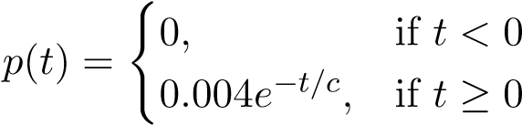

gives the probability density for the lifetime of these defective Albertine Unit 13 models, where c is a positive constant and t is measured in years since the robots are activated. Show all your work to receive full credit.
  - Interpret the quantity 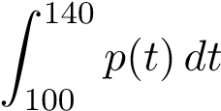.
  - Find the value of c.
  - What is the mean (average) lifespan of a defective Albertine Unit 13?

- If a particle of mass m is positioned at a perpendicular distance a from the center of a rod of length 2L and constant mass density δ as shown below
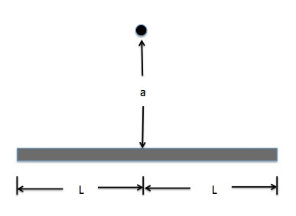
The force of gravitational attraction F between the rod and the particle is given by

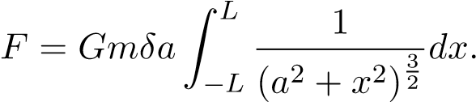

  - Does the force of gravitational attraction F approach infinity as the length of
the rod goes to infinity? Justify your answer using the comparison test.

  - Consider the integral
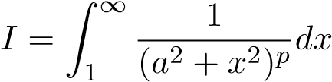

    - Give a power function that if integrated over [1, ∞) will have the same convergence or divergence behavior as I.
    - For what values of p is I convergent or divergent?

- A machine produces copper wire, and occasionally there is a flaw at some point along the wire. The length x of wire produced between two consecutive flaws is a continuous variable with probability density function

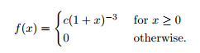

Show all your work in order to receive full credit.

  - Find the value of c.

  - Find the cumulative distribution function P(x) of the density function f(x).
Be sure to indicate the value of P(x) for all values of x.

  - Find the mean length of wire between two consecutive flaws.

  - A second machine produces the same type of wire, but with a different probability density function (pdf). Which of the following graphs could be the graph of the pdf for the second machine? Circle all your answers.

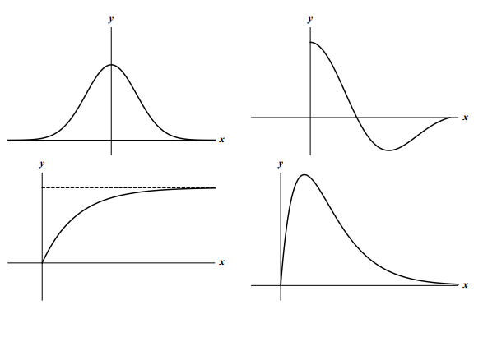

5. Suppose that the time in minutes that it takes Albertine to brush her teeth is given by:

- Find the constant c so that f is a pdf.
- Find the cdf of f.
- Find the probability that Albertine brushes her teeth for more than 3 minutes.
- Find the expected value (mean) of the time that it takes Albertine brushes her teeth.

