**WORKSHEET XIII**

More on Positive series

(Integral test, ratio Test, Root Test, Limit Comparison test)

1.  For each of the following series, ∑ an, determine *convergence* or *divergence*.  Justify each answer.











*Hint:* First, explain why, for small positive *x*, sin x > x/2.





































2. (a) Explain why the *sequence* n1/n converges. What is its limit?

(b) Show that the following *series* converges. (*Hint:* Use the root test.)



(c) Using the fact that the series in (b) converges, explain why n = *o*((ln n)n).

(d) Determine if the following series converges or diverges. (*Hint:* Use the Comparison Test.)



3. [University of Michigan]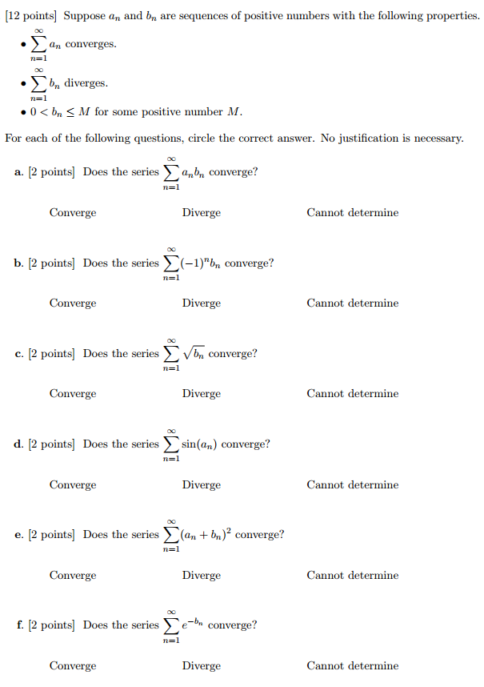

4. State [Stirling’s formula](https://en.wikipedia.org/wiki/Stirling%27s_approximation). Using Stirling’s formula write 100! in scientific notation.

*With the exception of the geometrical series, there does not exist in all of mathematics a single infinite series the sum of which has been rigorously determined. In other words, the things which are the most important in mathematics are also those which have the least foundation.*

- [Niels Henrik Abel](http://www-history.mcs.st-and.ac.uk/Biographies/Abel.html) (1802 – 1829)

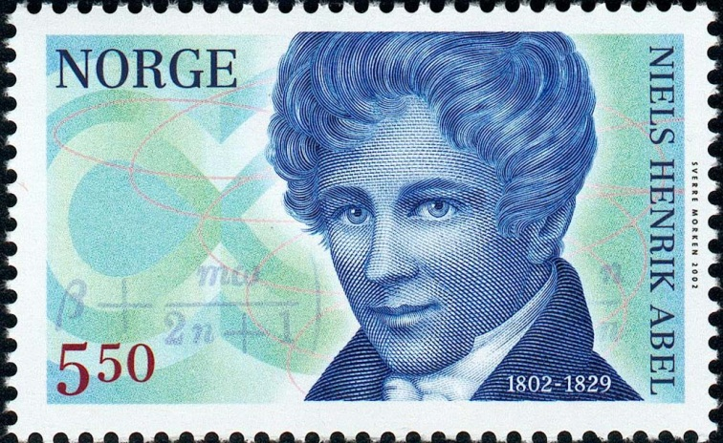

[Course Home Page](http://www.math.luc.edu/~ajs/courses/162spring2016/index.pdf)          [Department Home Page](http://www.math.luc.edu/)        [Loyola Home Page](http://www.luc.edu/)