Worksheet XIV

Absolute & conditional convergence

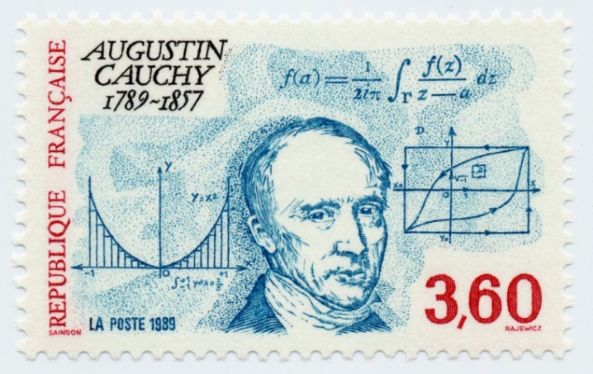

1. Explain how the *ratio* and *root* *tests* can be extended for series more general than positive series.
2. State the **Cauchy-Leibniz rule** for alternating series.
3. For each of the following series, determine *absolute* convergence, *conditional* convergence or *divergence*.

























1. (University of Michigan final exam problem)
   * 1. Determine whether the following series converge or diverge (circle your answer). For each, justify your answer by writing what convergence rule or convergence test you would use to prove your answer. If you use the comparison test or limit comparison test, also write an appropriate comparison function.

(i)

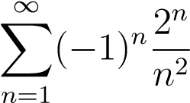 Converge Diverge

(ii)

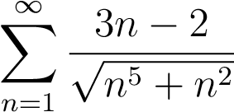 Converge Diverge

* + 1. Does the following series converge conditionally, absolutely, diverge or is it not possible to decide? Justify.

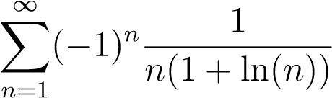

1. (University of Michigan final exam problem)

Determine whether the following series converge or diverge (circle your answer). Be sure to mention which tests you used to justify your answer. If you use the comparison test or limit comparison test, write an appropriate comparison function.

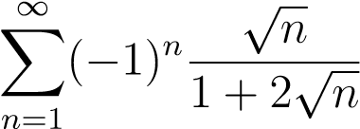

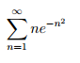

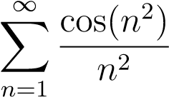

*A man is like a fraction whose numerator is what he is and whose denominator is what he thinks of himself. The larger the denominator, the smaller the fraction.*

– Leo Tolstoy