Worksheet XV

Power series

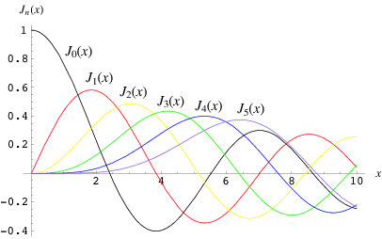

[*Bessel functions*](http://mathworld.wolfram.com/BesselFunctionoftheFirstKind.html) *may be expressed as power series*

1. For each of the following power series, determine the *interval of convergence*. Consider end-point behavior as well.

























1. *[University of Michigan Final Exam question]* Consider the following power series

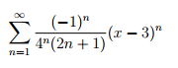

1. For which values of x does the power series converge?
2. For which values of x does the power series converge absolutely?
3. For which values of x does the power series converge conditionally?
4. *[University of Michigan Final Exam question]* Consider the following power series

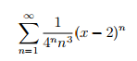

Find the interval of convergence of the power series. Justify your answer.

1. *[University of Michigan Final Exam question]* Consider the following power series

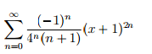

1. At x = −3, does the series converge absolutely, conditionally or diverge?
2. Using just your answer in (a), state the *possible* values for the radius of convergence R. Justify.
3. Find the interval of convergence of the series

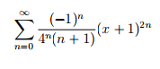

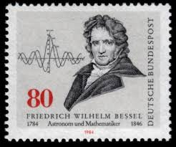

*If people do not believe that mathematics is simple, it is only because they do not realize how complicated life is.*

- John von Neumann