WORKSHEET XVII
Taylor polynomials, Taylor series
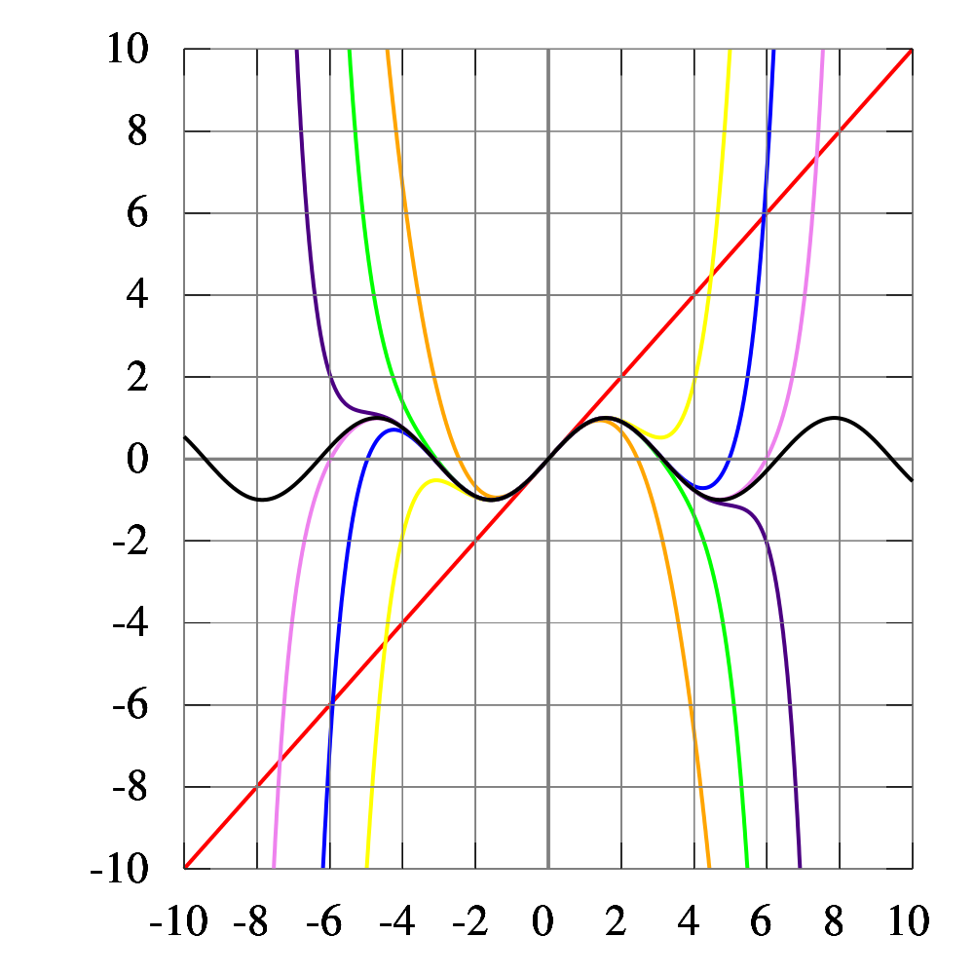
Wikipedia: As the degree of the Taylor polynomial rises, it approaches the correct function. This image shows sin(x) and its Taylor approximations, polynomials of degree 1, 3, 5, 7, 9, 11 and 13.

- Find the 5th order Maclaurin polynomial of e^{3x}.
- Find the 4th order Maclaurin polynomial of (1 – x) e^{x}.
- Find the 3rd order Taylor polynomial of 1/(1 + x²) centered
at c = 1.
- Find the 5th order Maclaurin polynomial of (3x – sin(3x))/x³.
- Find the first four non-zero terms of the Maclaurin series of exp(x² + x).
- Write the Maclaurin series expansion for x/(1 + x²) and for
ln(1 + x²). Find the interval of convergence for each series. What is the relationship between these two series?

- Using an appropriate power series expansion, compute
Σ n/7^{n}. (Hint: Differentiate an appropriate geometric series.)

- Find the Maclaurin series of each of the functions:
2/(3 – x), 5/(4 – x), and (23 – 7x)/ [(3 – x)(4 – x)].
- Find the 99th derivative of 1/(a – bx) by using an appropriate power series.

- Find the binomial expansion of (1 + x)⁻⁴. What is its radius of convergence?

- Find the Maclaurin series expansion of 1/(1 + x²)^{1/2}.

- Find the 23rd derivative of 1/(1 + x²)^{1/2}.

- Using an appropriate Maclaurin series, evaluate the limit of
(sin x – x)/x³ as x 0.

- Evaluate the limit of (sin x – tan x)/x³ as x 0 without using l’Hôpital’s rule.

- Evaluate the limit of (ln x) / (x – 1) as x 1 without using l’Hôpital’s rule.

- Evaluate the limit of 1/(sin x) – 1/x as x 0 without using l’Hôpital’s rule.

- Evaluate the limit of (sin x – x)/(tan x – x) as x 0 without using l’Hôpital’s rule.

- Evaluate the limit of ln x / (e^{x} – e) as x 1 without using l’Hôpital’s rule. (Hint: Let t = x – 1.)
- Find without using l’Hôpital’s rule.
- State Taylor's inequality. Using this inequality, prove that the Maclaurin series of e^{x}, sin x, cos x, and cosh x each converge to the given function everywhere.
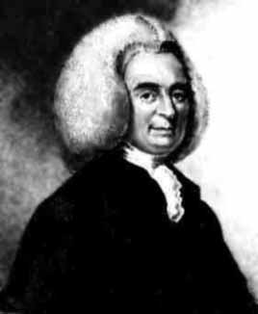
Colin Maclaurin (1698 – 1746)
Brook Taylor (1685 - 1731)

Course Home Page Department Home Page Loyola Home Page

