**WORKSHEET VIII**

***little oh and big oh***

Suppose that f(x) → ∞ and g(x) → ∞ as x → ∞. We say that “*f is of smaller order than g”* if  as x → ∞. In this case we write f = *o*(g).

Assume that *f* and *g* are each positive for large *x*. We say that “*f is at most the order of g”* if there is a positive integer *M* for which for large x. In this case we write f = *O*(g).

Determine which of the following statements are true; justify each answer.

(a) 3x2 + 11 = *o*(x5 + x + 99)

(b) x + 5 sin x = *O*(x)

(c) 2x = *o*(x100)

(d) 3x= *O*(ex)

(e) x = *o*(ln x)

(f) 

(g) 

(h) (x2+1)4 = *O*((2x+1)3x5)

(i) 

(j) ln x = *o*(ln(ln x))

(k) ln(x55+x33+x11+1) = *O*(ln x)

(l) (ln x)100 = *o*(x1/25)

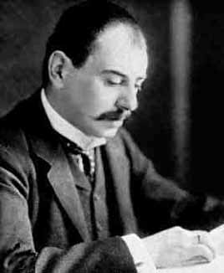

[Edmund Landau](http://www-gap.dcs.st-and.ac.uk/~history/Mathematicians/Landau.html) (1877 – 1938) is known for his work in

analytic number theory and the distribution of primes.

He first introduced the *little oh* notation in 1909.

[Course Home Page](http://www.math.luc.edu/~ajs/courses/162fall2016/index.pdf)          [Department Home Page](http://www.math.luc.edu/)        [Loyola Home Page](http://www.luc.edu/)