Math 162 Extra credit essay
(March 2018)

- What is the relation of the harmonic series to music? Develop this theme.

- Discuss the origin of the concept of logarithm. Should astronomers be given credit for developing this idea first?

- Choose one or two ideas in the mathematics of gambling and develop them.

- How are infinite series useful in solving differential equations? Give applications.

- Which specialties in medicine require knowledge of calculus, differential equations and physics? Develop these thoughts.

- Discuss the “Tristram Shandy paradox” How does this compare with Zeno’s paradox? Discuss related paradoxes such as the “barber paradox”.
- Discuss the ideas inherent in the paradox of Hilbert’s hotel. You may wish to read Vilenkin’s account of the extraordinary hotel.
https://yakovenko.files.wordpress.com/2011/11/vilenkin1.pdf (pages 39 – 47)

- The great Argentine writer Jorge Luis Borges was fascinated by the infinite. Read several of the short stories in Borges’ Labyrinths: Selected Stories and Other Writings. Discuss the relationship between the study of the infinite in the differential calculus and Borges’ vision of the infinite. Alternatively, write a short story in the style of Borges that engages the reader in a particular encounter with the differential calculus.

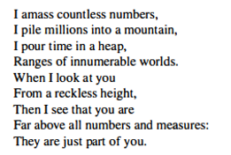
- Albert von Haller (1708 – 1777)

