SURVIVAL SHEET: Math 162 - section 005

Spring Semester 2018
Required Text: James Stewart, Calculus: Single Variable with Early Transcendentals, 8th edition, Cengage Learning (2016), packaged with WebAssign or WebAssign stand-alone.
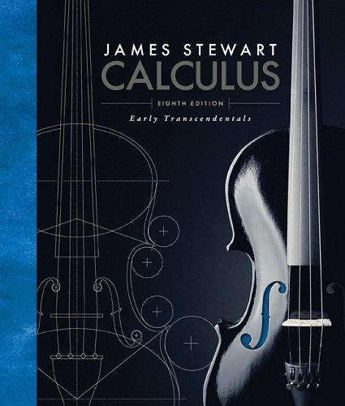

Calculator: The TI-83 Plus or TI-84 Plus graphing calculator or equivalent is required. The TI-89 and more powerful calculators are not permitted.
Software: Mathematica 11
Instructor: A. Saleski, 612 BVM Hall (contiguous with IES) building # 37 on map (6349 N. Kenmore Ave., Chicago, IL 60660)
e-mail: asalesk@luc.edu OR alan.saleski@gmail.com; office phone: (773) 508-3577
Teaching Assistant: Katie Busse <kbusse1@luc.edu>
Course URL: http://www.math.luc.edu/~ajs/courses/162fall2018/index.pdf
WebAssign: https://www.webassign.net/luc/login.html
Office Hours: TBA

Ground Rules: The final grade is computed according to the following recipe:

quizzes | 19 %
tests | 30 %
homework (WebAssign) | 7 %
homework (written) | 7 %
Mathematica labs | 5 %
groupwork | 3%
final exam | 29 %
Piazza | 3%

Grading scale:
A 90 – 100
A- 88 – 89
B+ 84 – 87
B 80 – 83
B- 75 – 79
C+ 70 – 74
C 65 – 69
C- 60 – 64
D+ 50 – 59
D 40 – 49
F 0 - 39

Tutoring Services:
“The Center for Tutoring and Academic Excellence offers FREE tutoring services to all LUC students! Our tutoring model includes small group tutoring and tutor-led study halls. The small groups meet once per week throughout the whole semester and are led by a trained peer tutor who has successfully completed study in the course material. Students are placed into a group with other students who are taking that same course and who share the same professor! Drop-in Study Halls are offered throughout the week for many LUC courses and begin the first week of classes. Our study hall schedule can be found online at: www.luc.edu/tutoring. To learn more about our services or to request small group tutoring, please visit the CTAE online at www.luc.edu/tutoring or drop by the Center during normal business hours, M–F 9am – 7pm. We are located in the Sullivan Center, 2nd floor, Room 245. Hope to see you soon!”

Important Dates:
• quizzes: most Fridays
- tests: 3 tests
• Holidays:
- Martin Luther King Day: Monday, Jan 15th
- Spring break: Monday – Saturday, March 5th – 10th
- Easter break: Friday – Monday, March 30th – April 2nd
• Last Day to Withdraw: Monday, March 26th (midnight)
• Last Day of Class: Friday, April 27th
• Study Day: Wednesday, May 2nd (ends at 4:15 pm)
• Final Exam: Thursday, May 3rd (1:00 – 3:00 pm)
• Loyola Calendar (Spring Semester of 2018)

Remarks:

- Piazza will be our main form of communication outside of class. Upon receiving your welcome message from Piazza, you should join. Any corrections, changes in office hours, “what to expect on a test or quiz”, etc., will be posted in Piazza. The system is highly catered to getting you help fast and efficiently from classmates, the TA, and myself. Rather than emailing questions to the teaching staff, you should post your questions on Piazza. If you have any problems or feedback for the developers, email team@piazza.com.

- All general questions/remarks/solutions should be posted in Piazza. If you wish to make a personal statement, it might be best to email me directly (although the option of private messages does exist in Piazza).

- Quizzes will be based upon material recently covered in class. Each quiz is given during the last 30 minutes of Friday’s class. The lowest two of the quiz grades will be dropped.

- The duration of each test is our full two periods. Make-up tests will be given only for non-frivolous reasons. In such cases, the student should make prior arrangements with the instructor, if at all possible.

- The minimum penalty for cheating is failure in the course. A student who improperly aids another with a homework assignment, a test, the essay, the final exam, or with a Mathematica lab is considered equally culpable. If you receive help on an assignment from anyone other than the instructor (this includes another student, a TA, a tutor, a family member, website, or friend), you should acknowledge this fact in a comment at the beginning of your homework or project. Incidents of academic dishonesty will be reported to the appropriate Dean.

The institutionalized values school instills are quantified ones. School initiates young people into a world where everything can be measured, including their imaginations, and, indeed, man himself. But personal growth is not a measurable entity. It is growth in disciplined dissidence, which cannot be measured against any rod, or any curriculum, not compared to someone else's achievement. In such learning one can emulate others only in imaginative endeavor, and follow in their footsteps rather than mimic their gait. The learning I prize is immeasurable re-creation.
- Ivan Illich, Deschooling Society

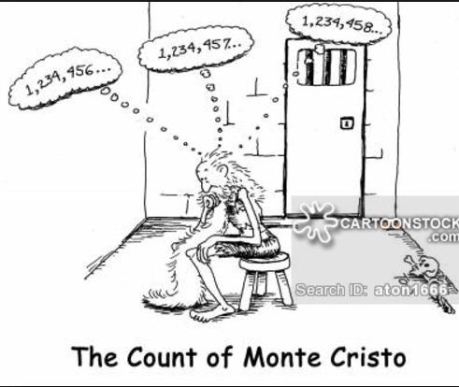

The goal of intellectual education is not to know how to repeat or retain ready-made truths (a truth that is parroted is only a half-truth). It is in learning to master the truth by oneself at the risk of losing a lot of time and of going through all the round about ways that are inherent in real activity.

Course Home Page Department Home Page Loyola Home Page

