Homework: MATH 162

HW 0 (due Wednesday, 24 January):
- Briefly relate (in one or two paragraphs) information about yourself that will help me get to know you. If you wish, you may let the following questions serve as a guide: When did you take Math 161 (or its equivalent)?; why are you taking Math 162 now? (for example: "major requirement", "just for fun because I love mathematics", "nothing else fits my schedule", "my parents forced me to take this course", "I am looking for an easy A to raise my gpa"); what is your major?; what is your career goal?; what has been the nature of your previous experience with math either in high school or in college (that is, have you enjoyed math in the past? Do you like to see applications more than theory, or do you prefer theory?).
(Please eMail your response to me no later than Friday. For “Subject” be certain to write “Math 162 HW 0”)

- Obtain an account in WebAssign.

- Register for Piazza.

- Review chapters 2 – 5 and section 6.1 of Stuart as needed. If your self-confidence in the method of substitution is low, pay particular attention to section 5.5 of Stuart.

HW 1 (due: Friday, 26 January) Study section 7.1 (integration by parts and reduction formulae). Watch the MIT lecture on integration by parts and reduction formulae. This is covered in roughly the last half of lecture 30: https://ocw.mit.edu/courses/mathematics/18-01-single-variable-calculus-fall-2006/video-lectures/lecture-30-integration-by-parts/

Australia Day, Jan 26, 2016 | Mozart’s birthday: January 27th

It's got to be the going, not the getting there that's good. – Harry Chapin, GO GREYHOUND
To travel hopefully is a better thing than to arrive. – Robert Louis Stevenson
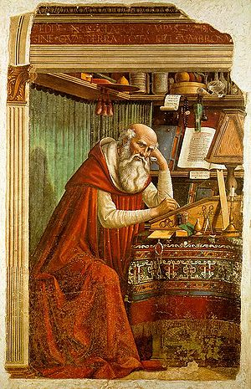
St. Jerome in His Study
Domenico Ghirlandaio (1480)

Course Home Page Department Home Page Loyola Home Page

