Math 162 - Calculus II

Spring 2018
Section 001: MWF 11:40 - 3:35 pm (118 Dumbach Hall)
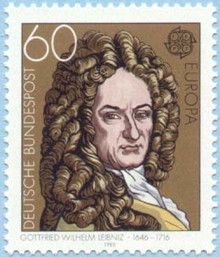
- Ground Rules
- Syllabus
- Homework & Reading Assignments
- Piazza
- Group Work
- Worksheets
- Tutoring Services and Schedule
- Practice Quizzes
- Practice Tests
- Mathematica Examples ( improper integrals, sequences, Taylor series, revolution)
- Mathematica Labs (Lab I)
- Quiz Solutions
- Test Solutions
- Useful References (Greek alphabet; Mathematica tutorials, relevant websites & supplementary texts)
- MIT OCW for Calculus
- History of Calculus

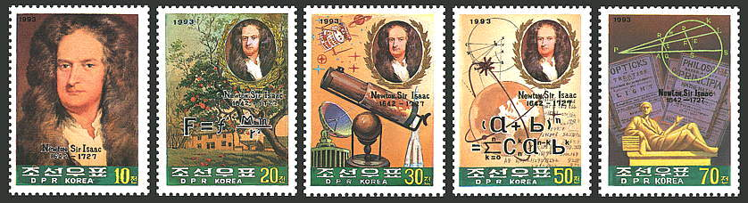

Department Home Page Loyola Home Page

