SURVIVAL SHEET: Math 201 – Section 002

Fall Semester 2015

Required Text:
Sarah-Marie Belcastro, Discrete Math with Ducks, 1st edition, CRC Press (2012).
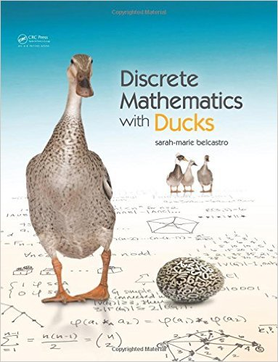

Calculator: Your favorite calculator is permitted.
Instructor: A. Saleski
612 BVM Hall (contiguous with IES) building # 37 on map (6349 N. Kenmore Ave., Chicago, IL 60660)
phone: (773) 508-3577
e-mail: asalesk@luc.edu or alan.saleski@gmail.com

Course URL: http://www.math.luc.edu/~ajs/courses/201fall2015/index.pdf
Office Hours:
MWF 2:00 – 4:30 pm
TTh 1:00 – 2:00 pm, 4:15 – 5:00 pm
or by appointment.
Ground Rules: The final grade is computed according to the following recipe:
quizzes | 13 %
tests | 25 %
homework | 23 %
group work in class | 15 %
final exam | 19 %
Piazza and extra credit | 5 %
Important Dates:
• Quizzes: September 10, 17; October 8; November 5
• Tests: September 24, October 22, November 19
• Holidays:
- Labor Day: Monday, 7th September
- Mid-semester break: Monday – Tuesday, October 5th – 6th
- Thanksgiving break: Wednesday – Sunday, November 25th – November 29th
• Last Day to Withdraw: Friday, October 30th (midnight)
• Last Day of Class: Thursday, December 3rd
• Study Day: Wednesday, December 9th
• Final Exam: Saturday, December 12th (4:15 – 7:15 pm)
• Loyola Calendar (Fall Semester of 2015)

Remarks:
- Piazza will be our main form of communication outside of class. Upon receiving your welcome message from Piazza, you should join. All general questions/remarks/solutions should be posted in Piazza. If you wish to make a personal statement, it might be best to email me directly (although the option of private messages does exist in Piazza).
- Late homework will be accepted but at a penalty of 10% per day late (this includes Saturday and Sunday).
- Quizzes will be based on recent class discussion and groupwork as well as recent homework. Each quiz will last about 15 minutes. There will be no make-up quizzes unless there are extraordinary circumstances.
- Each test is will be about 75 minutes long. Make-up tests will be given only for non-frivolous reasons. The student should make prior arrangements with the instructor, if at all possible.
- The minimum penalty for cheating is failure in the course. A student who improperly aids another with a homework assignment, a quiz, a test, the final exam, or with a project is considered to be equally culpable. If you receive help on an assignment from anyone other than the instructor (this includes another student, a TA, a tutor, a family member, website, or friend), you should acknowledge this fact in a comment at the beginning of your homework. Incidents of academic dishonesty will be reported to the appropriate Dean.

I'm not the sort of person who does my mathematics writing on paper. I do that at the last stage of the game. I do my mathematics in my head. I sit down for a hard day's work and I write nothing all day. I just think. And I walk up and down because that helps keep me awake, it keeps the blood circulating, and I think and think. (Sir Michael Atiyah)
Any good theorem should have several proofs, the more the better. (Sir Michael Atiyah)
I glory in the diversity of mathematics and the lack of a uniform straightjacket. (Sir Michael Atiyah, Bull. AMS, 2006, p. 87)
Mere proof won't convince me. (Caption to a cartoon by James Thurber)
If the people do not believe that mathematics is simple, it is only because they do not realize how complicated life is. (John von Neumann)
...for mathematical proofs, like diamonds, are hard and clear, and will be touched with nothing but strict reasoning. (John Locke, Second Reply to the Bishop of Worcester)
Mystery is an inescapable ingredient of mathematics. Mathematics is full of unanswered questions, which far outnumber known theorems and results. It's the nature of mathematics to pose more problems than it can solve. Indeed, mathematics itself may be built on small islands of truth comprising the pieces of mathematics that can be validated by relatively short proofs. All else is speculation. (Ivars Peterson, from a Mathematical Mystery Cruise)
Proof is an idol before whom the pure mathematician tortures himself. (Arthur Stanley Eddington, The Nature of the Physical World)
Do mathematics only if you are passionate about it, only if you would do it even if you had to find the time for it after a full day’s work in another job. Like poetry and music, mathematics is not an occupation but a vocation. (Béla Bollobás)
In mathematics you don't understand things. You just get used to them. (John von Neumann)
For in all sorts of reasoning every single argument should be managed as a mathematical demonstration (John Locke: Of the Conduct of the Understanding)
One thing that really fascinates me about mathematics is its very real permanence. It is essentially immortal...Once a theorem always a theorem would
summarize this viewpoint adequately. (A. B. Mingarelli)
Because of mathematics' precise, formal character, mathematical arguments remain sound even when they are long and complex. In contrast, common sense arguments can generally be trusted only if they remain short; even moderately long nonmathematical arguments rapidly become farfetched and dubious. (Jacob T. Schwartz, 'Discrete thoughts')
The problem with simple arguments is that they may be difficult to explain. (Karin Erdmann)

Course Home Page Department Home Page Loyola Home Page

