Handout 4 September 3, 2015

Truth Tables, Tautologies, and Logical Equivalence
(Bruce.IkenagaDepartment of Mathematics, Millersville University, Millersville, PA )

Mathematics normally works with a two-valued logic: Every statement is either True or False. You can use truth tables to determine the truth or falsity of a complicated statement based on the truth or falsity of its simple components.
A statement in sentential logic is built from simple statements using the logical connectives , , , , and .
(Note that in our class we use the symbol $¬$instead of ~.)
I'll construct tables which show how the truth or falsity of a statement built with these connective depends on the truth or falsity of its components.
Here's the table for negation:
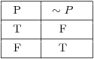
This table is easy to understand. If P is true, its negation is false. If P is false, then is {\it true}.
should be true when both P and Q are true, and false otherwise:
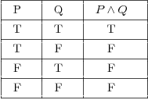
is true if either P is true or Q is true (or both). It's only false if both P and Q are false.
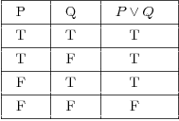
Here's the table for logical implication:
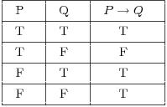
To understand why this table is the way it is, consider the following example:
"If you get an A, then I'll give you a dollar."
The statement will be true if I keep my promise and false if I don't.
Suppose it's true that you get an A and it's true that I give you a dollar. Since I kept my promise, the implication is {\it true}. This corresponds to the first line in the table.
Suppose it's true that you get an A but it's false that I give you a dollar. Since I didn't keep my promise, the implication is false. This corresponds to the second line in the table.
What if it's false that you get an A? Whether or not I give you a dollar, I haven't broken my promise. Thus, the implication can't be false, so (since this is a two-valued logic) it must be true. This explains the last two lines of the table.
means that P and Q are equivalent. So the double implication is true if P and Q are both true or if P and Q are both false; otherwise, the double implication is false.
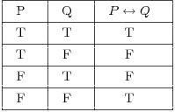
You should remember --- or be able to construct --- the truth tables for the logical connectives. You'll use these tables to construct tables for more complicated sentences. It's easier to demonstrate what to do than to describe it in words, so you'll see the procedure worked out in the examples.
Remarks. 1. When you're constructing a truth table, you have to consider all possible assignments of True (T) and False (F) to the component statements. For example, suppose the component statements are P, Q, and R. Each of these statements can be either true or false, so there are possibilities.
When you're listing the possibilities, you should assign truth values to the component statements in a systematic way to avoid duplication or omission. The easiest approach is to use lexicographic ordering. Thus, for a compound statement with three components P, Q, and R, I would list the possibilities this way:
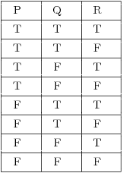
2. There are different ways of setting up truth tables. You can, for instance, write the truth values "under" the logical connectives of the compound statement, gradually building up to the column for the "primary" connective.
I'll write things out the long way, by constructing columns for each "piece" of the compound statement and gradually building up to the compound statement.

Example. Construct a truth table for the formula .
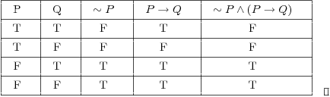

A tautology is a formula which is "always true" --- that is, it is true for every assignment of truth values to its simple components. You can think of a tautology as a rule of logic.
The opposite of a tautology is a contradiction, a formula which is "always false". In other words, a contradiction is false for every assignment of truth values to its simple components.

