**Homework:  MATH 201**

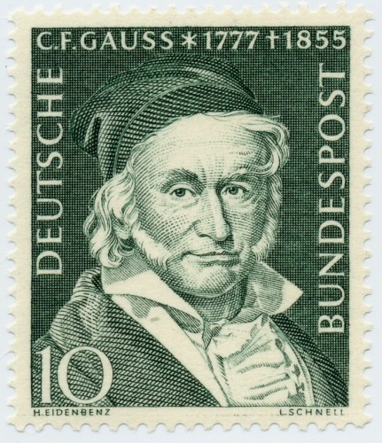

**Homework 0:** Due: Tuesday, 25 August

Briefly relate (in one or two paragraphs) information about yourself that will help me get to know you.  If you wish, you may let the following questions serve as a guide:  When did you take Math 161 and 162 (or their equivalents)?; why are you taking Math 201 now? (for example: *"major requirement", “minor requirement”, "just for fun because I love mathematics", "nothing else fits my schedule", "my parents forced me to take this course", "I am looking for an easy A to raise my gpa"*); what is your major?; what is your career goal?; what has been the nature of your previous experience with math either in high school or in college (that is, have you enjoyed math in the past?).   
(Please eMail your response to me no later than Wednesday. For “Subject” write “**201 Homework 0**”)

**Prep for Tuesday:** Read pp 1 – 3 of our text, **Discrete Math with Ducks**; then read the **Preface for Students and Other Learners**, pp xxix – xxxvii; then read the Preface again, but more carefully.

**Homework 1:** Due: Thursday, 27 August

Read the remainder of chapter 1 at least twice. Submit *carefully written solutions* to problems 4, 9 and 12 in section 1.7.

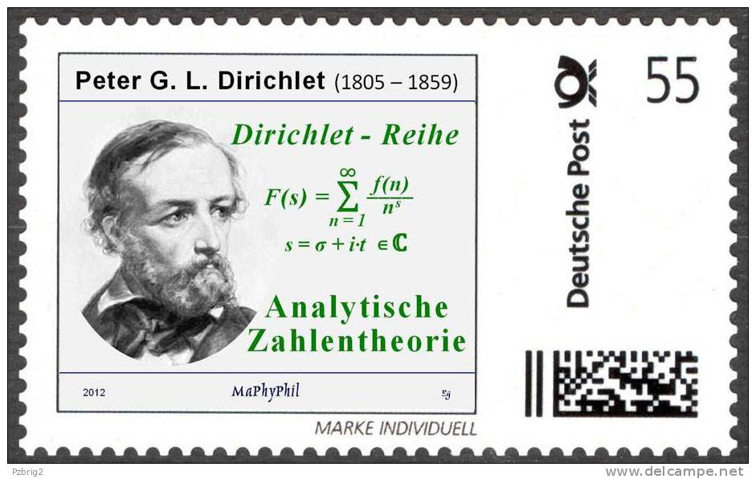

**Homework 2:** Due: Tuesday, 1 September

Submit *carefully written solutions* to problems 11, 17, and 23 on pp 20 – 22,

**Prep for Tuesday:** Read sections 2.1, 2.2, and 2.3 and attempt the Check Yourself Problems.

**Homework 3:** Due: Thursday, 3 September

Submit *carefully written solutions* to problems 11, 14, 18 on page 54.

**Prep for Thursday:** Review sections 2.1, 2.2, and 2.3 and carefully read the remaining portion of the Chapter. As usual, attempt the Check Yourself Problems.

**Homework 4:** Due: Tuesday, 8 September

Submit *carefully written solutions* to problems 10, 12, 23 on page 54.

**Prep for Tuesday:** Read sections 3.1 and 3.2 (pp 57 – 66) and do the Check Yourself problems on page 62. Following the author’s advice *I will assume that you have read and reread these pages*. In this way we can *begin* with GroupWork on Tuesday and see how it goes. **Prepare** for Quiz 1 on Thursday.

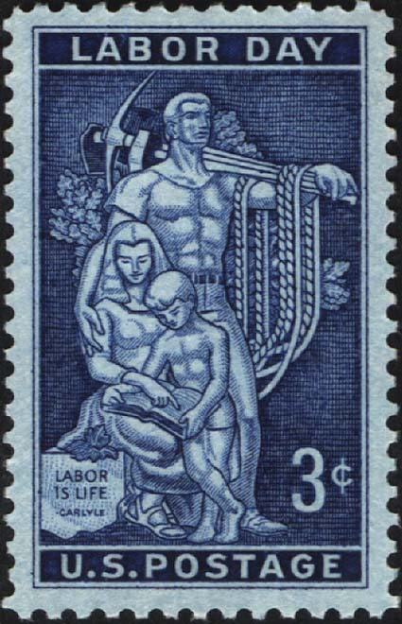

**Homework 5:** Due: Thursday, 10 September

Submit *carefully written solutions* to problems 7 and 12 on page 86.

***Preparation for Quiz I*:**  The quiz will be given during the last 20 minutes of class. It will focus upon definitions, examples, and statements of principals/theorems. There will be no proofs.

**Prep for Thursday:** Read sections 3.3 – 3.7 and, and usual, do the Check Yourself problems. Reflect further upon the “dot game” described in section 3.3. We will play this game on Thursday.

**Homework 6:** Tuesday, 15 September

Study the remainder of chapter 3.

**Homework 7:** Due: Thursday, 17 September

Submit *carefully written solutions* to the following two problems remaining from problem set 6:

For each function answer the following five questions.

1. Is it well-defined?
2. Is it surjective?
3. Is it injective?
4. Is it bijective?
5. Is it an isomorphism?
6. Let X and Y each be the set of complex numbers endowed with the usual addition and multiplication for complex numbers. Note, here each set has two operations.

Define H: X → Y as follows: For all zX H(z) = conjugate of z.

1. Let X be the set of real numbers endowed with the usual addition. Let Y be the set of all positive real numbers endowed with the usual multiplication.

Define T: X → Y as follows: For all sX T(s) = 2s.

**Prep for Thursday:** Read sections 4.1 and 4.2 and do the Check Yourself problems on page 100. *I will assume that you have read and reread these pages*. Thus we can *begin* with GroupWork on Thursday.Quiz 2 will be *take-home* due the following Tuesday.

|  |  |  |
| --- | --- | --- |
|  |  |  |
| Patriot Day, Sept 11 |  | Rosh Hashana (Sept 13) |



**Homework 8:** Due: Tuesday, 22 September

Review sections 4.1 and 4.2. Read the remainder of the chapter (through page 114) as time permits.

Reminder: submit your solutions to quiz 2.

|  |  |
| --- | --- |
|  |  |
| 23 September 2015, 4:21 am EDT |  |

**Homework 9:** Due: Thursday, 24 September

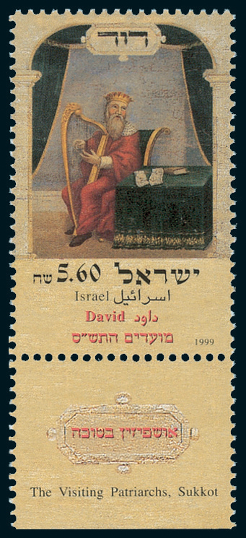

Read sections 5.1 – 5.4. Do the “check yourself” exercises

We will explore equivalence relations on Thursday.

*Chinese mid-autumn festival: 27 September 2015*

**Homework 10:** Due: Tuesday, 29th September

Review chapter 5 (particularly sections 5.3 and 5.4).

Do the “check yourself” exercises on pages 130 and 137.

*Explore the three ciphers:* Caeser, Atbash, Vigènere

**Submit problems 5.5 (1a, 1b, 2c)** on pp. 37, 38



*Prepare for Test 1 on Thursday (in-class & take-home).*



[*Ibn ad-Duraihim (1312 – 1361) discovered the method of frequency analysis*](http://ciphermachines.com/types.html)

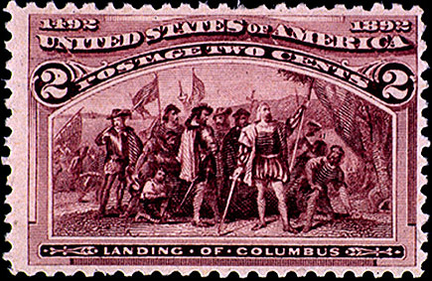

**Homework 11:** Due: Tuesday, 14th October

Read sections 6.1 through 6.5 of our text, answering the Check Up problems as you go along.

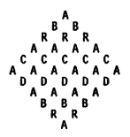

For Homework, determine the *number* of different ways there are to spell out “ABRACADABRA” always going from one letter to an adjacent letter in the mystical sign of the left?

**Homework 12:** Read sections 7.1, 7.2, 7.3 and 7.4, doing the Check Yourself exercises before going on to a new section.

Solve and submit problems 1 and 5 on page 208.  Explain every step of your reasoning (else little or no credit will be given)



**Homework 13:** Due: Tuesday, 27th October

Read sections 8.1 through 8.7 of our text, answering the Check Up problems as you go along. Submit solutions to 16 (a, *b and d*) on page 247



**Homework 14:** Due: Thursday, 5th November

Read pp. 17 – 25 of Burton’s [Elementary Number Theory](http://www.scribd.com/doc/248847166/BURTON-David-M-Elementary-Number-Theory-7th-Ed#scribd)

Try to solve the first 12 exercises on page 24-25

**Homework 15:** Due: Tuesday, 10th November

Read pp. 26 – 31 of Burton

Submit exercises 6 and 9 on page 19 of Burton. Also, make sure you can solve the computational exercises 1 and 2 on page 31.

**Homework 16:** Due: Tuesday, 17th November

Read pp. 39 – 43, 46, and 88 of Burton

Submit exercises 7 and 10 on page 43 of Burton.



**Homework 17:** Due: Tuesday, 24th November

Prepare for Test 3 on number theory. Read chapter 15 of Ducks.

Review Fermat’s little theorem.

1. Using Fermat’s Little Theorem, compute 51234 (mod 19).
2. Prove that 22225555 + 55552222 ≡ 0 (mod 7). (*Hint:* First evaluate 1111 (mod 7).)

*The seeming absence of any ascertained organizing principle in the distribution of the succession of the primes had bedeviled mathematicians for centuries and given Number Theory much of its fascination. Here was a great mystery indeed, worthy of the most exalted intelligence: since the primes are the building blocks of the integers and the integers the basis of our logical understanding of the cosmos, how is it possible that their form is not determined by law? Why isn't 'divine geometry' apparent in their case?*

                         - A. Doxiadis, from the novel **Uncle Petros and Goldbach's Conjecture**, p. 84 (Faber 2000)

[Course Home Page](http://www.math.luc.edu/~ajs/courses/201fall2015/index.pdf)          [Department Home Page](http://www.math.luc.edu/)        [Loyola Home Page](http://www.luc.edu/)