Math 201 - Elementary Theory of Numbers

(aka Discrete Mathematics)

Fall Semester 2015
Section 002: TTh 2:30 – 3:45 pm (406 Mundelein Center)

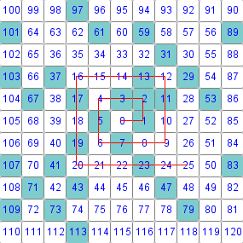

the prime spiral (aka the Ulam spiral)
Notice that the blue numbers (all primes but for 1) tend to line up along diagonal lines.
In a passage from his 1956 novel The City and the Stars, author Arthur C. Clarke describes the prime spiral seven years before it was discovered by Ulam.
Clarke did not notice the pattern revealed by the prime spiral because he never actually performed the experiment.

- Ground Rules
- Piazza
- Homework & Reading Assignments
- Homework Solutions (#1, #2, #3, #4, #5, #6)
- Groupwork (ps1, ps2, ps3, ps4, ps5, ps6, ps 7, ps 8, ps 9, ps 9.5, ps 10, ps 11, ps 12, ps 13, ps 14, ps 15, ps16)
- Quiz Solutions (Qz1)
- Final Exam topics
- Test Solutions (T1-A, T2-A, T3-A)
- Useful References (Discrete Mathematics & Number Theory websites; Supplementary texts)
- History of Number Theory

On the other hand, it is impossible for a cube to be written as a
sum of two cubes or a fourth power to be written as a sum of two
fourth powers or, in general for any number which is a power
greater than the second to be written as a sum of two like powers.
For this I have discovered a truly wonderful proof, but the margin
is too small to contain it.

– P. Fermat

Department Home Page Loyola Home Page

