Problem set 11: recurrence relations

Let F_{n} be the n^{th} Fibonacci number. (Let us assume that F₁ = F₂ = 1.)

- Using induction prove that, for all nN, $1+\sum_{k=1}^{n}{F_{k}=F_{n+2}}$
- Using induction prove that, for all nN, $F_{n-1}F_{n+1}={(F}_{n})^{2} +{(-1)}^{n}$
- Find a formula for the sum of the first n odd-index Fibonacci numbers (F₁, F₃, F₅, ...). Prove your conjecture.
- Find a formula for the sum of the first n even-index Fibonacci numbers (F₂, F₄, ...). Prove your conjecture.
- Prove that $F_{n+3}{=2F}_{n+1}+F_{2}F_{n}$
- Find a recurrence formula that defines the sequence 2, 5, 8, 11, 14, ...

- Find a closed form expression for each of the following sequences:
- 1, -3, 9, -27, 81, ...
- -6, -1, 4, 9, 14, ...
- 1, 8, 27, 64, 125, ...

- Find a closed form expression for the sequence: a₀ = 8, a_{n} = a_{n-1} – 4

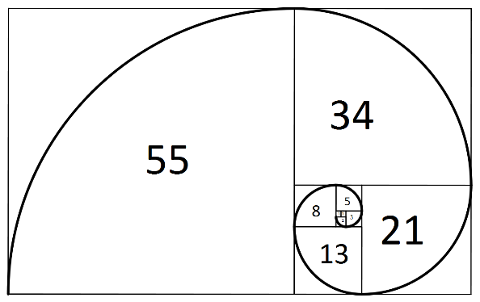
Fibonacci spiral

Mathematicians have tried in vain to this day to discover some order in the sequence of prime numbers, and we have reason to believe that it is a mystery into which the human mind will never penetrate.

- Leohard Euler (1707-1783)

Course Home Page Department Home Page Loyola Home Page

