Problem set 12: Divisibility, the gcd & LCM

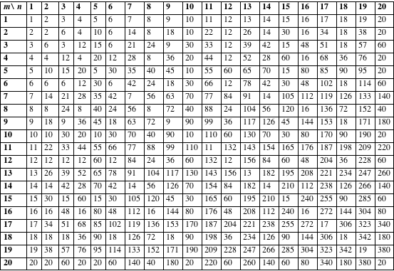

Part I:
Each of the following statements is either True or False. Considering several examples, try to decide which is the case. If False, provide a counterexample; if True, try to give a complete proof. Unless otherwise indicated, all literals (a, b, c, etc.) represent positive integers.

- a|a, a|0, 1|a
- If a| (bc) then either a|b or a|c.
- If a|(b+c) then either a|b or a|c.
- If a|b and c|d then ac | bd.
- If a|b and a|c then a|(b+c).
- If a|b and a|c then a|(sb+tc).
- If a|b then a³ | b³.
- If a|b and b|a then a = b.
- If a|b and a|c then a|(b+c)
- If a|b and a|c then a|(bx+cy) for any integers x and y.
- Let p be a prime. If p² | a² then p|a.
- If a|b and c|b then ac | b.
- If a|b and b|c then a|c.
- Define gcd(a, b) for any integers a and b, assuming they are not both 0.
- gcd(a+1, a) = 1.
- gcd(a+2, a) = 1 or 2.
- gcd(x, y) = gcd(x – y, y).
- If a|b and c|d then ac | bd.
- If a|b then ac | bc.
- If (ac) | (bc) then a|b.
- If n is of the form 3K+1, then n² is of the form 3L+1.
- If n is of the form 3K+2, then n² is of the form 3L+1.
- Let p be a prime. If p | ab then p|a or p|b. (Here we must make an assumption about prime numbers.)
- If n is of the form 5K+3, then n² is of the form 5L+1.
- Consider any two consecutive natural numbers. One of the two must be even.
- Consider any three consecutive odd natural numbers. One of the three must be divisible by 3.
- Consider any five consecutive odd natural numbers. One of the five must be divisible by 5.
- Let n be larger than 5. Then n² – 25 cannot be prime.
- Let n be larger than 3. Then n³ – 8 cannot be prime.

Part II:
  - State the well-ordering principle.
  - State and prove the Division Algorithm, assuming the divisor is positive.
  - Prove that gcd(x, y) = gcd(x – y, y).
  - Prove that, given integers a and b, not both 0, there exist integers x and y such that gcd(a, b) = ax + by.
  - Deduce from (3) that given integers a and b, not both 0, the set
T = {ax + by: x and y are integers} equals the set of all multiples of the gcd(a, b).
  - Explain the significance of the following calculations:
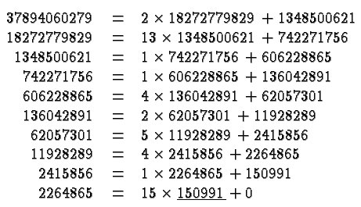

The theory of Numbers has always been regarded as one of the most
obviously useless branches of Pure Mathematics. The accusation is one against which there is no valid defense; and it is never more just than when directed against the parts of the theory which are more particularly concerned with primes. A science is said to be useful if its development tends to accentuate the existing inequalities in the distribution of wealth, or more directly promotes the destruction of human life. The theory of prime numbers satisfies no such criteria. Those who pursue it will, if they are wise, make no attempt to justify their interest in a subject so trivial and so remote, and will console themselves with the thought that the greatest mathematicians of all ages have found it in it a mysterious attraction impossible to resist.

- G. H. Hardy from a 1915 lecture on prime numbers

Course Home Page Department Home Page Loyola Home Page

