Problem set 13: extended GCD, fermat’s little theorem

  - Let a and b be integers, not both 0. Define gcd(a, b).
  - Find gcd(2584, 1597)
  - Prove that gcd(a, b) = gcd(a – kb, b) for any integer, k.
  - Using the extended Euclidean algorithm, find integers x and y such
that ax + by = gcd(a, b) when:
- a = 34, b = 459
- a = 272, b =4356
- a = 156 b = 572
  - Using the extended Euclidean algorithm, find integers x and y such that 3789406027x + 18272779829y = gcd(37894060279, 18272779829). Of course, the calculation below is of great help.
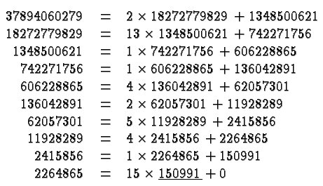

- State the well-ordering principle.

- State and prove the division algorithm.

- Let a and b be integers, not both 0. Prove that there exist integers x and y such that ax + by = gcd(a, b)
.
- Give Euclid’s proof that there exist infinitely many primes.

- $Prove Pythagoras'$ theorem$that \sqrt{2}$ is irrational.
- Prove that a and b are relatively prime if and only if there exist integers x, y for which ax + by = 1.

- Euclid’s lemma: Prove that if c divides ab and c is prime then c divides a or c divides b.
Is this statement still true if one removes the hypothesis that c is prime?
What if one assumes that gcd(b, c) = 1 ?

- State Fermat’s theorem.

- Using Fermat’s theorem show that 17 is a divisor of 11¹⁰⁴ + 1.

- State the Fundamental Theorem of Arithmetic.

- Given non-zero integer a, prove that gcd(a, a+1) = 1

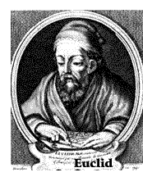

Course Home Page Department Home Page Loyola Home Page

