Problem set 16: the Cantor-Schroeder-Bernstein Theorem

Study the proof below (from: Art of problem solving):

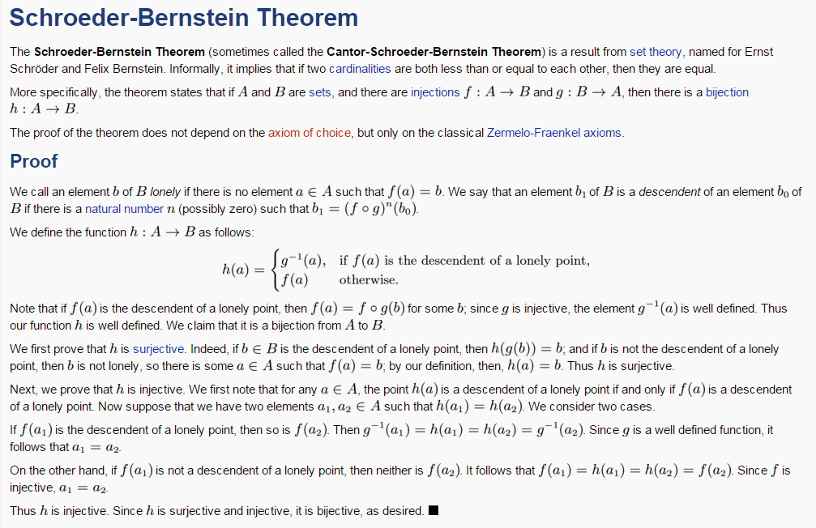

I For each problem below, first explain why f and g are injections. Then, identify the “lonely” points and (try to) identify the “descendants” of each lonely point. Finally, show how h: A B is defined.

- Let f: N N be defined as follows: f(a) = a+3.

Let g: N N be defined as follows: g(a) = a.

(Of course, here g is a bijection. But in this elementary example. we want to illustrate how h: N N is defined.)

- Let f: N N be defined as follows: f(a) = a+1.

Let g: N N be defined as follows: g(a) = a+1.

- Let f: N N be defined as follows: f(a) = a+2.

Let g: N N be defined as follows: g(a) = a+1.

Let f: N N be defined as follows: f(a) = 2a

Let g: N N be defined as follows: g(a) = 2a+1.

- Let f: N Z be defined as follows: f(a) = a

Let g: Z N be defined as follows:

- Let f: Z Z be defined as follows: f(a) = 3a

Let g: Z Z be defined as follows: g(a) = 3a+1.

History (Wikipedia)
The traditional name "Schröder-Bernstein" is based on two proofs published independently in 1898. Cantor is often added because he first stated the theorem in 1895, while Schröder's name is often omitted because his proof turned out to be flawed while the name of Richard Dedekind, who first proved it, is not connected with the theorem. According to Bernstein, Cantor had suggested the name equivalence theorem (Äquivalenzsatz).
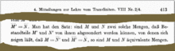
Cantor's first statement of the theorem (1887)
- 1887 Cantor publishes the theorem, however without proof.
- 1887 On July 11, Dedekind proves the theorem (not relying on the axiom of choice) but neither publishes his proof nor tells Cantor about it. Ernst Zermelo discovered Dedekind's proof and in 1908 he publishes his own proof based on the chain theory from Dedekind's paper Was sind und was sollen die Zahlen?
- 1895 Cantor states the theorem in his first paper on set theory and transfinite numbers. He obtains it as an easy consequence of the linear order of cardinal numbers. However, he couldn't prove the latter theorem, which is shown in 1915 to be equivalent to the axiom of choice by Friedrich Moritz Hartogs.
- 1896 Schröder announces a proof (as a corollary of a theorem by Jevons)
- 1896 Schröder publishes a proof sketch^{[14]} which, however, is shown to be faulty by Alwin Reinhold Korselt in 1911^{[15]} (confirmed by Schröder).
- 1897 Bernstein, a 19 years old student in Cantor's Seminar, presents his proof.
- 1897 Almost simultaneously, but independently, Schröder finds a proof.
- 1897 After a visit by Bernstein, Dedekind independently proves the theorem a second time.
- 1898 Bernstein's proof (not relying on the axiom of choice) is published by Émile Borel in his book on functions. (Communicated by Cantor at the 1897 International Congress of Mathematicians in Zürich.) In the same year, the proof also appears in Bernstein's dissertation.
Both proofs of Dedekind are based on his famous memoir Was sind und was sollen die Zahlen? and derive it as a corollary of a proposition equivalent to statement C in Cantor's paper which reads A ⊆ B ⊆ C and |A|=|C| implies |A|=|B|=|C|. Cantor observed this property as early as 1882/83 during his studies in set theory and transfinite numbers and therefore (implicitly) relying on the Axiom of Choice.

