**Math 201 Problem sheet 3 1 September 2015 Name:_________________ Group:_____**

**PART I (review):** The **power set** of a set A is defined to be the set of all subsets of A. Recall that if A is a finite set then |A|, the number of members of A, is referred to as the **cardinality of A**.

1. Let A = {0, 1}, Find P(A) by listing all the subsets of A.

.

1. Let B = {Jack, Queen, King, Ace}. Find P**(B)**
2. If |C| = n, what is the cardinality of P**(C) ?**
3. If D is the empty set (denoted by φ), what is the cardinality of D? What is the cardinality of P**(D)**?

**PART II** (naive set theory)

1. Let A = {n Z | n = 2d + 5 for some dZ} and Let B = {n Z | n = 2p - 1 for some pZ}. Are sets A and B equal? Why or why not?
2. Let A = {all 5-letter words (in Oxford American Dictionary) that have at least 3-vowels}, let B = {all 5-letter words (in Oxford American Dictionary) that have at least 3-consonants}, let C = {all 5-letter words (in Oxford American Dictionary) that have no more than 2 consonants}

Does A = B? B = C? A = C?

1. Let A = {0, 1, 4, 7}, B = {1, 2, 3, 11, 13}, C = {0, 2, 7, 14}, D = {0, 19}. List the elements of each of the following sets:

AB, AD, AB, BD, A BC D, A (BC), A\C, C\A, D\A, D\B

1. Prove, in general, that (A B) C = A (B C)
2. Assume that AB and BC, does it follow that AC? Explain.
3. Prove that A\ (BUC) = (A\B) (A\C)
4. Find a counterexample to: A\(B\C) = (A\B)\C

**Part III** (quantifiers)

**(A)** Define the following symbols: ∃ and ∀. Convert each of the following statements into one that uses quantifiers. Assume that *X*, *A*, *B*, *C* are sets.

1. For every *x* in *A* there exists *y* *B* satisfying the condition that 3*x* > *y*.
2. For all *x* *A* and all *y* *B* there exists *z* *C* satisfying the condition *x* < *z* < *y*.
3. For each *a* *A* there is a *b* *B* such that, for every *c* C, *c* > *a*+*b*.
4. There exists an *x* *X* such that for all *y* *A* there exists a *z* in *B* such that *x < z < y*.
5. For every *p* *A* there exists a *q* in *B* such that for all *r* in X either *r* < 3*p* or *r* > 5*q*.

**(B)** Translate each of the following into an English sentence.

1. 
2. 
3. 
4. 

**(C)** Let A, B, C and X be sets. Negate each of the following sentences.

1. 
2. 
3. 
4. 

**IV** (logic) *Once master the machinery of Symbolic Logic, and you have a mental occupation always at hand, of absorbing interest, and one that will be of real use to you in any subject you may take up. It will give you clearness of thought - the ability to see your way through a puzzle - the habit of arranging your ideas in an orderly and get-at-able form - and, more valuable than all, the power to detect fallacies, and to tear to pieces the flimsy illogical arguments, which you will so continually encounter in books, in newspapers, in speeches, and even in sermons, and which so easily delude those who have never taken the trouble to master this fascinating Art.*

- Lewis Carroll

Let P be the statement “it is raining today” and Q be the statement “I brought my umbrella”. Give the meaning of each of the following statements. Write each statement as a sentence.

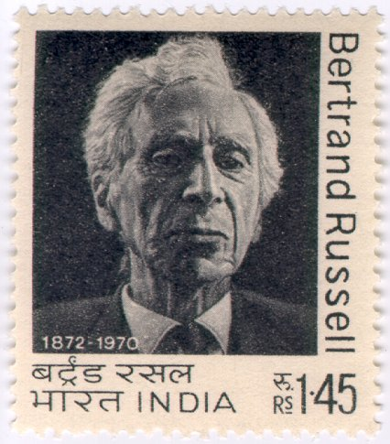

[Bertrand Russell](http://plato.stanford.edu/entries/russell), British philosopher, logician, essayist, and social critic, is perhaps best known for his work in mathematical logic and analytic philosophy. [Gottlob Frege](http://plato.stanford.edu/entries/frege)'s earlier treatment of quantification went largely unnoticed until Bertrand Russell's 1903 **Principles of Mathematics**.

[Course Home Page](http://www.math.luc.edu/~ajs/courses/201fall2015/index.pdf) [Department Home Page](http://www.math.luc.edu/) [Loyola Home Page](http://www.luc.edu/)