Math 201 Problem sheet 4 3 September 2015

- If Albertine lives in Tianjin then Albertine lives in China.
Express as a logical statement. (That is, define propositions P and Q and then write as an if-then implication PQ.)
Write the converse. Is it True?

Write the contrapositive. Is it True?

Write the inverse. Is it True?

- If two angles are congruent, then they have the same measure.
Same questions as in (a).

- If a quadrilateral is a rectangle, then it has two pairs of parallel sides.
Same questions as in (a).

- If Albertine buys Halloween decorations, then Gilberte raises bats in her basement.

2. Prove (some of) the following tautologies by means of a Truth Table.)
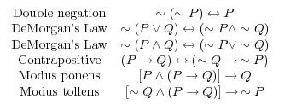

3. Let P = “I love algebra”, Q = “I like spiders”, and R = “I am vegetarian”.

Write the following symbolically and then make a truth table.

“If I love algebra or like spiders then I am not a vegetarian.”

Georg Cantor, father of modern set theory

Course Home Page Department Home Page Loyola Home Page

