Math 201 Problem set 5 8 September 2015

I Solve the following exercises from our text:
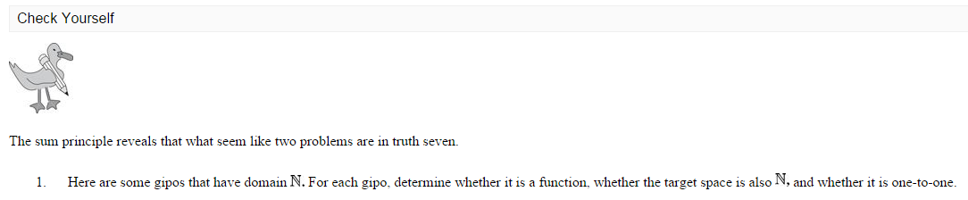
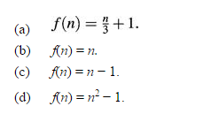

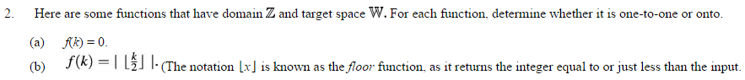
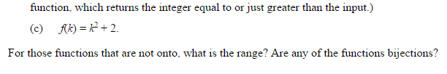
II In the following, let N, Z, Q, R denote the set of natural numbers, the set of integers, the set of rational numbers, and the set of real numbers, respectively. For each function “candidate” below, first determine if it is well-defined. If so, then determine if it enjoys any of the properties of being injective, surjective, bijective.
- F: N → N given by F(n) = n + 1

- G: N → N given by G(n) = n – 1

- H: Z→N given by H(m) = |m|

- f: Z→N given by f(m) = |m| + 1

- α: Q → Z given by α(a/b) = a + b

- β: Q → Z given by β(x) = ab where x = a/b (where a and b are nonnegative) or –a/b (where a and b are nonnegative) and gcd(a,b)=1

- F: N → N given by F(n) = n²

- G: R → R given by G(x) = (x – 1)(x – 2)(x – 3)

- H: Z → Z given by H(m) = z + 11

- id: X → X given by id(m) = m

- p: N → Q given by p(j) = 1/j

- F: N → Q given by F(n) = n/13

- z: N → N given by z(m) = sum of the digits in the decimal representation of m.

III Let A and B be finite sets and let f be a function f: A → B. Prove that if |A| > |B| then f cannot be injective.

Course Home Page Department Home Page Loyola Home Page

