Math 201: problem set VI
Isomorphism
- Let X be a set endowed with operation and let Y be a set endowed with operation . (It is assumed, of course, that each set is closed under its own operation).
(Sometimes X and Y will have multiple operations.)

An isomorphism is a bijection : X → Y that preserves operations.
More precisely: For all x₁ and x₂ X, ( x₁ x₂) = (x₁) (x₂).
For example, let X be the space of 21 (column) vectors with real entries, endowed with the usual matrix addition. Let Y be the space of 1 2 (row) vectors, also endowed with the usual matrix addition.
Define $Φ\left(\left[\begin{matrix}a \\ b\end{matrix}\right]\right)=\left[\begin{matrix}a & b\end{matrix}\right]$

Prove that $Φ$ is an isomorphism.

- Consider the following function : → defined by the rule, for all a, $Φ$ $\left(a\right)=a+1$.
Assume that operation on Z is addition in both the domain and target.
- Is well-defined?
- Is surjective?
- Is injective?
- Is bijective?
- Is an isomorphism?

Investigate each of the following functions by going through the list of five questions in #2.

- Let X be the space of all polynomials with real coefficents.
Let X and Y have one operation: polynomial addition.
Define F: X → Y by the following rule: for all p X, F(p) = F’

- Are the following two graphs isomorphic?
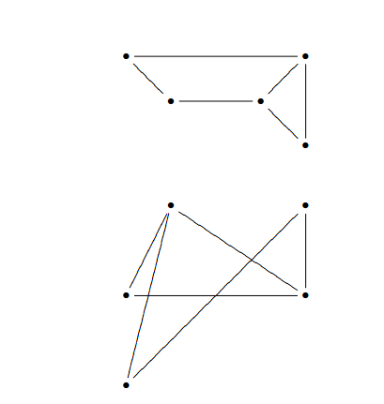
- Let X be the set of polynomials of degree 2 or smaller with real coefficients, endowed with the usual addition of polynomials. Let Y be the set of 31 column vectors, endowed with the usual matrix addition. Define G: X → Y as follows: For all a, b, cR G(a + bx + cx²) = $\left[\begin{matrix}a \\ b \\ c\end{matrix}\right]$.
- Let X and Y each be the set of complex numbers endowed with the usual addition and multiplication. Note, here each set has two operations.
Define H: X → Y as follows: For all zX H(z) = conjugate of z.

- Let X be the set of real numbers endowed with the usual addition. Let Y be the set of all non-negative real numbers endowed with the usual multiplication.
Define T: X → Y as follows: For all sX T(s) = 2^{s}.

- Are the following two graphs isomorphic?
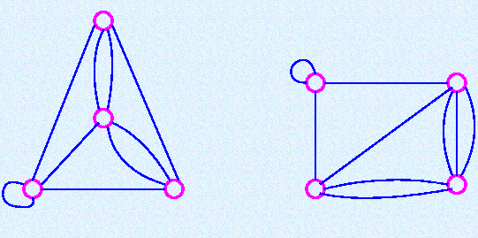
11. Are the following two graphs isomorphic?
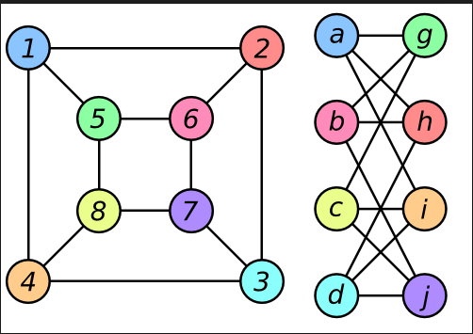

The origins of graph theory are humble, even frivolous.
- N. Biggs, E. K. Lloyd, and R. J. Wilson (Graph Theory: 1736-1937)

