Problem set 9.5: Combinatorics

- Give a combinatorial proof for each of the two identities:

The latter identity is known as “Pascal’s identity” even though many mathematicians had “discovered” it before Pascal was born.

- Give a combinatorial proof of Vandemonde’s identity, viz.

- Consider the word POISSON.
- Find the number of arrangements of this word.
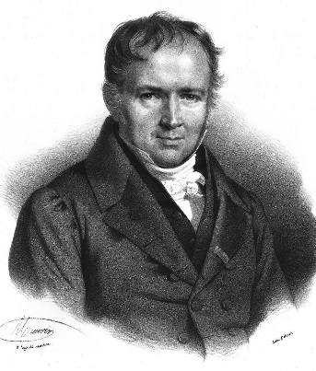

Simeon Poisson (1781-1840)

- Find the number of arrangements if the two Ss must be together.
- Find the number of arrangements if the two Os must be apart.
- Find the number of arrangements if the two Ss must be together and the two Os not together.
- Given a group of 13 married couples. In how many ways can one choose a subset of 5 individuals from this group which contains no married couple?

- In how many ways can A, B, C, D, E, F line up if
- A must be in front of B?
- A must be in front of B and B must be in front of C?
- Philanthropist David Quiche wishes to distribute 7 golden eggs, 6 silver spheres, and 5 platinum cubes to 4 lucky children. In how many different ways can he distribute these precious objects to the four children? (Hint: First consider only the golden eggs.)

- Albertine is teaching Chem 105 this semester. She has a total of 100 students in her class. Taking a survey (via Piazza) she finds that 28 students like dogs, 26 like cats, and 16 like rats. There are 12 students who like cats and dogs, 4 who like dogs and rats, and 6 who like cats and rats. Only 2 students like dogs, cats and rats. How many students do not like any of the 3 animals: dogs, cats, rats.

- In how many ways can 8 people be seated in a row if
- there are exactly 5 men and they must sit next to one another?
- there are 4 married couples and each couple must sit together?

- Three distinguishable dice are thrown. In how many ways can the maximum of the 3 numbers occurring equal 5?

- State and prove by induction the binomial theorem.

- Can you discover a similar theorem for trinomials: (a + b +c)^{n} where nN?

- Twenty-five students show up at the OZ Fitness & YOGA Center looking for open classes. Only 3 classes are still open: one has 8 spots, one has 11 spots, and one has 6 spots. In how many different ways can the students be arranged in the 3 classes?

- Albertine lives in a city with a square grid of numbered streets which run east-west and numbered avenues that run north-south. Her house is located on the corner of 0th Street and 0th Avenue. Odette, her aunt, lives at the corner of 5th St. and 3rd Ave.

(a) How long is the shortest route (along streets or avenues) to her aunt’s house?
How many direct routes can Sally take to her aunt’s house?

(b) There is an ATM machine at the corner of 2nd St. and 2nd Ave. If Albertine needs to stop at the store on her way to her Aunt’s, how many direct routes to her Aunt’s house take her through the intersection of 2nd St. and 2nd Ave?

- At her Aunt’s house Albertine hears on the radio that there has been an accident at the corner of 1st St. and 2nd Ave. Assuming that she avoids this intersection, how many direct routes can Albertine take home?

Course Home Page Department Home Page Loyola Home Page

