Math 201 Class discussion: 23 January 2019

Propositional logic (aka sentential logic)

Truth Tables, Tautologies, and Logical Equivalence
(adapted from B. Ikenaga, Department of Mathematics, Millersville University, and from Srini Devadas & Eric Lehman, MIT 6.042)
Mathematics normally works with a two-valued logic: Every proposition is a statement that is either True or False. You can use truth tables to determine the truth or falsity of a complicated statement based on the truth or falsity of its simple components.
Which of the following English statements are ambiguous and which are propositions?
- You may have cake, or you may have ice cream.
- If pigs can fly, then you will become president of the USA.
- Study hard!
- This sentence is false.
- I hate falling asleep in class.
- If Mars is called “the red planet”, then Mars is made of red pepper.
- If you can solve any problem we come up with, then you will be given an A in this course.
- Every American has a dream.
- If 1+ 5 = 6, then 8 + 12 = 20.
- If 1 + 5 = 13, then 8 + 12 = 2019.
- If Albertine is not watching Colbert’s Late Show “live” on TV, then today is not Monday.
- If intelligent life exists on the recently discovered exoplanet, Proximal b, then I will die young.
- I am terrified of large spiders.
- If hell freezes over, then The Game of Thrones will never end.

A statement in sentential logic is built from simple statements using the logical connectives$∼$, $∧$ ,$∨, ⇒, and⇔$
We construct tables which show how the truth or falsity of a statement built with these connectives depends on the truth or falsity of its components.
Here's the table for negation:
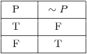
This table is easy to understand. If P is true, its negation $∼P$ is false. If P is false, then $∼P$ is true.
Next, $P⋀Q$should be true when both P and Q are true and false otherwise:
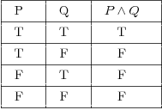
$Next, P∨Q$ is true if either P is true or Q is true (or both). It's only false if both P and Q are false.
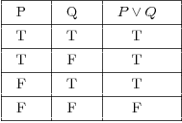
Here's the table for logical implication:
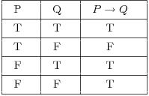
To understand why this table is the way it is, consider the following example:
"If you get an A, then I'll give you a dollar."
The statement will be true if I keep my promise and false if I don't.
Suppose it's true that you get an A and it's true that I give you a dollar. Since I kept my promise, the implication is true. This corresponds to the first line in the table.
Suppose it's true that you get an A, but it's false that I give you a dollar. Since I didn't keep my promise, the implication is false. This corresponds to the second line in the table.
What if it's false that you get an A? Whether or not I give you a dollar, I haven't broken my promise. Thus, the implication can't be false, so (since this is a two-valued logic) it must be true. This explains the last two lines of the table.

Finally, $P⇔Q$means that P and Q are equivalent. So the double implication is true if P and Q are both true or if P and Q are both false; otherwise, the double implication is false.
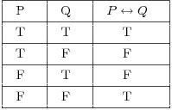
You should remember --- or be able to construct --- the truth tables for the logical connectives. You'll use these tables to construct tables for more complicated sentences. It's easier to demonstrate what to do than to describe it in words, so you'll see the procedure worked out in the examples.
Remarks. When you're constructing a truth table, you have to consider all possible assignments of True (T) and False (F) to the component statements. For example, suppose the component statements are P, Q, and R. Each of these statements can be either true or false, so there are 2³ = 8 possibilities.
When you're listing the possibilities, you should assign truth values to the component statements in a systematic way to avoid duplication or omission. The easiest approach is to use lexicographic ordering. Thus, for a compound statement with three components P, Q, and R, I would list the possibilities this way:
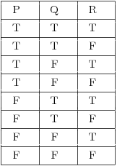
There are different ways of setting up truth tables. You can, for instance, write the truth values "under" the logical connectives of the compound statement, gradually building up to the column for the "primary" connective.
We will write things out the long way, by constructing columns for each "piece" of the compound statement and gradually building up to the compound statement.

Example. Construct a truth table for the formula $∼P∧(P⇒Q)$
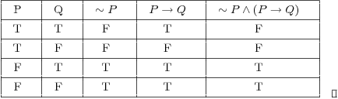

A tautology is a formula which is "always true" --- that is, it is true for every assignment of truth values to its simple components. You can think of a tautology as a rule of logic.
The opposite of a tautology is a contradiction, a formula which is "always false". In other words, a contradiction is false for every assignment of truth values to its simple components.
What is the converse of an implication? The contrapositive of an implication? The inverse of an implication?
What are closed sentences? Open sentences?

Examples: Closed Sentences:
A square has four corners |  | always true
6 is less than 5 |  | always false
−3 is a negative number |  | always true

Open Sentences:
A triangle has n sides |  | Can be true or false (depending on the value of n)
z is a positive number |  | Can be true or false (depending on the value of z)
3y = 4x + 2 |  | Can be true or false (depending on the values of x and y)
a + b = c + d |  | Can be true or false (depending on the values of a,b,c,d)
Exercises:
- Generate a truth table for each of the following statements.
- $A∨ ∼B$
- $P⇒ ∼Q∨R$
- $∼A∨B⇒ ∼C$
- $(A∧ ∼B)⇒(C∨D)$

- Exercises from Hammack (Section 2.1)
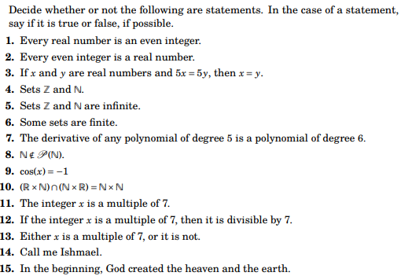

- Exercises from Hammack (Section 2.2)
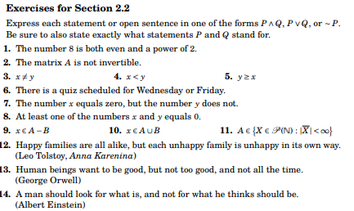
4. Convert each statement below into symbolic form and generate its truth table.
- The sun is hot, but it is not humid.
- If Albertine doesn't pass, then she will lose her scholarship and drop out of school.
- If it rains and you don't open your umbrella, then you will get wet.
- If your car won't start or you don't wake up on time, then you will miss your interview, and you will not get the new job.
- If you elect Odette then Odette will make sure that the federal budget will be balanced, partisan wrangling in Washington will cease, and there will be no cuts in social security benefits.
- If the cake gets hot, the icing melts, and if the icing melts, the cake cannot be used at the wedding reception.
5. Prove, using a truth table, that the following compound mathematical sentence is true, for all possible truth values of P, Q, and R:
((P⇒Q) $∧$ (Q ⇒R)) ⇒ (P⇒R)
6. Verify each of the following tautologies:

- de Morgan’s laws
(a) Prove $∼\left(A∧B\right)⇔\left(∼A\right)∨(∼B)$
(b) Prove $∼\left(A∨B\right)⇔\left(∼ A\right)∧(∼B)$
- The law of detachment: (P $∧$ (P⇒Q)) ⇒ Q
- The law of double negation $∼(∼P) ⇔P$
- The contrapositive $(P⇒Q)⇔(∼Q⇒ ∼P)$
- Modus ponens $[P∧\left(P⇒Q\right)]⇒Q$
- Modus tollens $[∼Q∧\left(P⇒Q\right)] ⇒ ∼P$
7. Is the following argument valid or invalid?
North Korea will invade China only if Turkey goes to war with Iran.
Turkey will not go to war with Iran.
So, North Korea will invade China.

8. Is the following argument valid?
Either government taxes will go up, or inflation will go up.
Inflation will not go up.
So, government taxes will go up.
9. Is the following argument valid?
France will go to war with Italy only if India and Japan both invade Russia.
France will go to war with Italy.
So, Japan will invade Russia.
10. Are the following statements logically equivalent?
- Swann is not tall.
- Either Swann is not tall, or Albertine is short.
11. Is the following statement a tautology?
Either it is not the case that Gilberte will not go to school or Gilberte will not go to school.
12. Is the following argument valid?
Lucky will buy a house only if Pozzo buys a car.
Pozzo will buy a car only if Estragon buys a motorcycle.
Estragon will not buy a motorcycle.
So, Lucky will not buy a house.

13. (a) Write the truth table for $Q∧R∧\sim P.$
(b) Write the truth table for $P∨\sim Q∨\sim R$
(c) Write the truth table for $P∨\sim Q∨\sim R$
(d) Write the truth table for $\left(Q∧\sim P\right)⇒R$

